**Chapter One**

**INTRODUCTION**

# 1.1 Background

Theobroma cacao, often known as cocoa, is a member of the Sterculia family and is believed to have originated from Mexico and other regions in tropical America (Manu, 1989). The crop in question has significant economic value within the equatorial region and is widely cultivated in regions adjacent to the Gulf of Guinea in West Africa. These regions include nations such as Ghana, Nigeria, Cote d’Ivoire, Liberia, Sierra Leone, Togo, and Benin (Wessel & Quist-Wessel, 2015). Cocoa is classified as an evergreen plant that often grows in the lower canopy of forests, mostly found in tropical climates. The optimal growth conditions for this cash crop are found in regions characterized by an average temperature range of 24 to 28 degrees Celsius (Maguire-Rajpaul et al., 2022). Additionally, the cultivation of these trees necessitates the presence of deep soils that can be easily penetrated by their tap roots. These soils should also possess good drainage capabilities and a moderate capacity for water retention. It is crucial that the total pore spaces within the soil range between 60 to 70 percent to ensure adequate aeration. Furthermore, the soil should be nutrient-rich and maintain a pH value within the range of 6.0 to 7.5, as specified by Amponsah-Doku et al. (2022).

Furthermore, cocoa is considered to be a very flavorful meal that is abundant in catechin and epicatechin compounds, which have been identified as contributors to its preventive attributes (Nair, 2010). Due to its dual nature, it has the third position internationally as a beverage, behind tea and coffee. Additionally, it possesses broader applicability and use (Orisajo, 2009). Cocoa mass serves as a critical ingredient in the production of chocolate, biscuits, and confectionery products. On the other hand, cocoa butter finds use in the creation of sweets, chocolate, fragrances, and pharmaceuticals (Ploetz, 2007). The use of the pod husk, a by-product, encompasses its incorporation into animal diets and its application as a fertilizer.

Cocoa is cultivated in several nations throughout South and Central America, Africa, Asia, and Oceania. Cocoa farming is often found throughout the latitudinal range of 10° north and south of the equator. The item in question has significant value and is regarded as highly esteemed. Its beans serve as a prominent export commodity for several nations located in West Africa (Bhattacharjee & Lava Kumar, 2007). The present valuation of the global cocoa business is projected to be $73 billion, with an annual cocoa output of 3.8 million metric tons globally (Lanaud et al., 2009). According to Orisajo (2009), the cocoa production in West African countries constitutes around 70% of the global market. The agricultural sector of Ghana has seen a notable transformation since the arrival of cocoa (Theobroma cacao) in the 1880s, with the crop continuing to have a substantial influence on the country's socio-economic growth. Among the several species of cocoa, Theobroma cacao has significant economic importance and serves as a key cash crop in Ghana (Mossu, 1992).

Cocoa production is conducted in around six of the ten regions within the nation, namely the Volta region, Central region, Brong-Ahafo region, Eastern region, Ashanti region, and the Western region. These areas together provide approximately fifty percent of the yearly cocoa output (Anim-Kwapong & Frimpong, 2005). In Ghana, the cultivation of cocoa encompasses three primary varieties: Amelonado, Amazonia, and Hybrid. The Amelonado and Amazonia cocoa varieties have a maturation time of around five (5) years before they begin to produce fruit (Lundstedt & Pärssinen, 2009). In contrast, the hybrid variety needs just three (3) years of gestation. Cocoa production constitutes around 55% of the overall revenue generated by families engaged in cocoa cultivation (Ghana Statistical Service, 2013). Furthermore, cocoa, being one of the primary export commodities in Ghana, contributes to 3.2% of the country's Gross Domestic Product (GDP) and 12% of its agricultural GDP, as stated by the Ministry of Food and Agriculture (MOFA, 2013). Ghana is responsible for 24% of the overall global cocoa exports, positioning it as the second-largest cocoa producer worldwide (Pipitone, 2012).

In Ghana, it is common to see two distinct cocoa production seasons, characterized by specific harvesting times, occurring annually. The agricultural calendar consists of two distinct seasons: the main crop season, which occurs from October to March, and the mid-crop season, which takes place from May to August (Tsiboe et al., 2014). The process of cocoa cultivation encompasses a sequence of tasks that span from initial planting through ongoing care, eventual harvesting, further drying, and ultimately bagging the beans for commercial distribution. Ghana held the position of the primary cocoa producer over a period of sixty-six years, spanning from 1911 to 1977. During this time, Ghana's market shares in cocoa production ranged from 30 to 40 percent, as reported by Naminse et al. (2011). The cocoa beans originating from Ghana are renowned for their exceptional quality and rich, complex taste profile. According to Hutchins et al. (2015), cocoa beans from this particular country have a higher content of theobromine and flavonoids compared to beans sourced from other nations. As a result, the International Cocoa Organization (ICCO) has recognized these beans as the global benchmark for evaluating the quality of cocoa.

Moreover, historical data reveals that cocoa production saw a significant growth trajectory, rising from 36.3 Metric Tons (MT) in 1891 to around 557,000MT in 1964/65. This surge in production positioned Ghana as a dominant player in the worldwide cocoa market, with a market share of approximately 33 percent, solidifying its status as the top cocoa producer during that period (Naminse et al., 2011). Subsequently, the output saw a continuous decline and eventually hit its nadir at 158,956 metric tons during 1983/84, accounting for a mere 9 percent of the global production. The decrease in productivity was notably impacted by several factors, including the severe drought experienced in 1983, inadequate farm care methods, the cultivation of low-yielding crop types, and the prevalence of pests and diseases (Amoah, 2013). The poor remuneration received by Ghanaian cocoa farmers has been linked to inadequate farm management methods (Dormon et al., 2004). Despite being the greatest cocoa-producing continent, West Africa's cocoa business has encountered several challenges, notably a decline in output resulting from the detrimental impact of diseases and pests on the cocoa crop. The predominant pest species that pose a significant threat to cocoa growers is the capsid insect, with the shield stink bug being the subsequent concern, maybe referring to the cocoa shield bug. The early ripening of cocoa pods is attributed to the feeding activity of the cocoa shield insect, which primarily inhabits the higher regions of the cocoa tree (Dormon et al., 2007).

The cocoa industry in West and Central Africa plays a significant role in the economic well-being of over two million smallholder farmers and approximately 10 million individuals. These individuals heavily depend on cocoa as their primary source of income or as a crucial component of their livelihoods. Therefore, the establishment of a robust and sustainable cocoa industry in the region presents a promising avenue for fostering economic growth and mitigating poverty (Huetz-Adams et al., 2016). One significant challenge to the realization of this ambition is the pervasive Cocoa Swollen Shoot Virus Disease (CSSVD), which is rapidly proliferating in Côte d’Ivoire, Ghana, Nigeria, and Togo. The illness in question is a plant virus that is prevalent in West Africa and has the ability to infect cocoa plants at many stages of growth, including seedlings, young trees, and mature trees. This virus is known as the Cocoa Swollen Shoot Virus Disease (CSSVD) (Ameyaw, 2019). The emergence of CSSVD may be traced back to its first occurrence in Ghana in 1936. Within a relatively short span of seven months, an estimated area of around 500km2 was documented as being severely affected, as recounted by Domfeh et al. (2011).  The transmission of the virus occurs via the feeding activities of mealybugs, an insect species, on cocoa trees (Domfeh et al., 2011). It is well acknowledged among scientists that some types of trees found in forest ecosystems may serve as hosts for the causative agent of the Coffee Swollen Shoot Virus Disease (CSSVD). The collaborative efforts of the governments of Côte d’Ivoire and Ghana were declared on August 23, 2018, with the aim of effectively addressing the issue of Cocoa Swollen Shoot Virus Disease (CSSVD) as documented by Kroeger et al. (2017). The authors characterized the CSSVD danger as akin to natural calamities such as tsunamis and earthquakes and emphasized the need for growers to consent to the treatment of their crops. Kroeger et al. (2017) noted that a significant proportion of Ghana's cocoa regions, namely 16.5% or over 300,000 hectares, have already been affected by the virus. In response to this situation, the government has devised a plan to provide an approximate sum of US$33 million for the purpose of replacing 22,850 hectares of infected cocoa plantations around the nation over the next two-year period. According to Kroeger et al. (2017), the government of Côte d'Ivoire has planned to undertake the removal of over 100,000 hectares of cocoa fields affected by infection over the next three years. This endeavor is projected to incur an estimated expenditure of around US$19 million.

Throughout the years, cocoa has emerged as a significant agricultural commodity that has played a pivotal role in sustaining the economy of Ghana. Cocoa production in Ghana is mainly concentrated in the Western Region, accounting for more than 60% of the total output (Kolavalli & Vigneri, 2011). The cocoa producers in these regions mainly engage in the cultivation of mixed Amazon or related varieties (Domfeh et al., 2011). The cocoa industry is plagued by several obstacles, including crop damage caused by pests and diseases, a decline in production, health, and environmental issues, the prevalence of child and forced labor in agricultural operations, and persistent poverty within farming communities (Hainmueller et al., 2011). In addition, it is worth noting that the cocoa plant (Theobroma cacao L.) is susceptible to five significant diseases, namely Phytophthora pod rot (commonly known as black pod), witches' broom, cacao swollen shoot virus, vascular streak dieback, and monilia pod rot. These diseases collectively contribute to an annual yield loss of more than 40% across various cocoa production regions (Nair, 2021).

CSSVD stands out as the most significant disease affecting cocoa cultivation in West Africa (Andres et al., 2017). The presence of a virus is responsible for the manifestation of symptoms in the leaves, stems, and roots of the affected plants. The export and processing of some cash crops, such as cocoa, have been identified as significant factors leading to low income (Cilas & Bastide, 2020). Furthermore, it is worth noting that CSSVD has emerged as a significant obstacle to cocoa production in many West African nations, including Benin, Liberia, Sierra Leone, Nigeria, Cote D'Ivoire, and Togo (Cilas & Bastide, 2020).

Andres et al. (2017) documented that the disease's first discovery may be traced back to the Eastern Region of Ghana in 1936. The most severe forms of the disorder have the potential to diminish crop production by around 70% significantly (Ameyaw et al., 2014). Additionally, these severe versions of the disease may lead to the death of the cocoa tree within a span of 2-3 years after infection, regardless of the stage of cocoa development. Based on the findings of Baah and Anchirinah (2011), the Cocoa Health and Extension Division (CHED) of Ghana reported the removal of about 28,486,309 obviously diseased and 'contact' cocoa plants across the nation over the period spanning from October 2006 to September 2010. A total of 18,332,234 trees, or 64.4% of the total, were harvested from the northern region of the Western Region exclusively, whilst the southern region contributed just 6.1% (Baah & Anchirinah, 2011). The regions of Eastern, Central, and Ashanti in Ghana had growth rates of 10%, 8.8%, and 6.6% correspondingly. The areas with the lowest rates of tree removal were the Volta region (1.7%) and the Brong Ahafo region (2.3%) (Baah & Anchirinah, 2011).

Several strains of Cassava brown streak disease (CSSVD) have been identified, including badnavirus, N1, and SS365B, as reported by Andres et al. (2017). The presence of some strains of infection resulted in a decline in the productivity of fully-grown trees (Ofori et al., 2022). Specifically, the yield reduction was observed to be 25% after one year, 50% after two years, and almost complete after three years. It is worth noting that by this point, the majority of infected trees either perish or show signs of impending demise. The Cocoa Swollen Shoot Virus Disease (CSSVD) has caused the demise of a significant number of cocoa plants, with the disease's propagation remaining largely unhindered in the region of widespread contamination. Since its discovery in 1936, the disease has inflicted significant damage on cocoa fields in Ghana. Over the last 50 years, over 200 million visibly affected and 'contact' trees have been removed from around 130,000 hectares of land as a means of management (Adomako, 2007). Nevertheless, it is worth noting that CSSVD continues to be widespread and has successfully disseminated over all cocoa cultivation areas in Ghana (Dzahini-Obiatey et al., 2010).

The emergence of Geographic Information Systems (GIS) tools and technology has significantly contributed to the identification, quantification, and resolution of many issues. Geographic Information Systems (GIS) also provide a proactive approach to problem-solving by doing research on potential scenarios and applying preventative strategies. Over the course of time, Geographic Information Systems (GIS) have enhanced the overall well-being of individuals in various domains such as telecommunications and network services, analysis of accidents and incidents, urban planning, transportation planning, assessment of environmental impact, estimation of flood damage, management of natural resources, and promotion of environmental health and safety, among numerous other areas. Moreover, Geographic Information Systems (GIS) are used to gather and analyze geospatial data, which is then used to calculate attribute information for the purpose of predicting occurrences and events, as well as evaluating environmental appropriateness.

Consequently, this study employs Geographic Information Systems (GIS) and remote sensing methodologies to evaluate the many elements that impact the environmental appropriateness of the Cocoa Swollen Shoot Virus Disease (CSSVD) in the Dadiesoaba and Akontonbra Districts of Ghana, using the Weighted Overlay Analysis approach.

# 1.2 Problem Statement

The cocoa business in Ghana, being a significant pillar of the country's economy, has several obstacles. One notable difficulty is the prevalence of illnesses, including black pod, stem canker, and cocoa swollen shoot virus, with the latter being the most prominent. Numerous methodologies or tactics have been used in an endeavor to manage or completely halt the rapid dissemination of the virus. Nevertheless, a limited number of research have tried to evaluate the influence of environmental and climatic variables on the transmission dynamics of the virus.

This project aims to investigate the environmental factors that impact the prevalence of CSSVD in certain cocoa regions in Ghana. Additionally, it aims to build an early warning system that may effectively restrict the spread of the virus. Consequently, the outcomes of this research will provide the Government and Ghana Cocoa Board (COCOBOD) with a valuable tool for assessing the efficacy of intervention programs aimed at enhancing cocoa output in Ghana.

Over the course of time, several methodologies have been used in the implementation of CSSVD control. However, little efforts have been made towards the management and surveillance of the disease's geographic distribution, as well as the exploration of its associated environmental suitability variables. The potential locations for the reintroduction of CSSVD remain uncertain, as stated by Lartey (2013). The cocoa industry is currently grappling with determining where an outbreak might start and where it might spread next. Since the first identification of the disease in Ghana in 1936 (Domfeh et al., 2011), the government has allocated significant resources towards the mitigation of CSSVD. Consequently, the allocation of financial resources and personnel towards the eradication of the disease through the removal of diseased trees and occasionally neighboring "contact" trees has resulted in a diversion of these resources from their potential utilization in enhancing husbandry practices, increasing cocoa production, and fostering improvements in other crops within the food industry (Ameyaw, 2019).

Although CSSVD has been prevalent in Ghana for over eight decades, the suitable environmental conditions that are likely to influence its development and transmission are not well understood. Moreover, its patterns and distribution over the nation is not well known. Furthermore, there are no vulnerability maps of the disease over the nation to help in developing effective mitigation strategies that will address several Sustainable Development Goals.

# 1.3 Objectives of study

## 1.3.1 General Objective

The main aim of this research is to investigate the environmental suitability for the spread of CSSVD within the two selected cocoa districts in Ghana.

## 1.3.2 Specific objectives

* To identify the spatial distribution of disease in the area.
* To ascertain the ecological and climate variables that contribute to the spread of the disease.
* To develop a vulnerability risk map for the disease transmission.

## 1.3.3 Research questions

* Which areas are prone to the disease in Ghana?
* What factors contributes to the spread of the disease?
* Are there identifiable indicators in the early stages that may aid in the efficient control and mitigation of the virus?

# 1.4 Organization of the Study

The research is organized into five primary chapters. Chapter one includes an introduction, a description of the issue, the research purpose, research questions, the scope of the investigation, and the relevance of the study. Chapter two provides a comprehensive assessment of the environmental suitability study of the swollen shoot disease. The study examines existing literature on the taxonomy and origin of cocoa, as well as the significant obstacles encountered by the cocoa business in Ghana. It also explores the detrimental impact of CSSVD and the environmental variables contributing to the disease's propagation. Chapter three of the study encompasses the methodology used, while chapter four focuses on the comprehensive analysis and subsequent discussion of the gathered results. Chapter five of the study addresses its conclusions and recommendations.

# Chapter Two

# ENVIRONMENTAL SUITABILITY ANALYSIS OF THE SWOLLEN SHOOT VIRUS

# 2.1 Introduction

This chapter provides a comprehensive review of the existing literature, including studies conducted by previous researchers as well as articles that are pertinent to the present study. The text provides readers with an update on the prevailing circumstances regarding the dissemination of CSSVD in Ghana. The study also examines the disease's origins in West Africa and Ghana, its genetic variability, early indicators and symptoms, and the environmental conditions conducive to the emergence of CSSVD. Additionally, it examines the preventative control measures used for the condition.

# 2.2 Taxonomy and Origin of Cocoa

The plant species known as cacao, scientifically referred to as Theobroma cacao, is categorized under the genus Theobroma, which is classified under the subfamily Sterculioidea of the botanical family Malvaceae. Cacao is classified as one of the 22 species belonging to the genus Theobroma. The etymology of the generic name may be traced back to Greek terms that signify nourishment bestowed upon deities (Afoakwa, 2016). Theobroma cacao, often known as the cocoa tree, is a compact evergreen tree from to the Malvaceae family. It is indigenous to the deep tropical areas of Central and South America (Beckett, 2019). The cacao pod, referred to as a fruit, has an oval shape with dimensions of around 15–30 cm in length and 8–10 cm in width. As it matures, the pod transitions from a yellow to orange hue and attains a weight of approximately 500 g when it reaches ripeness (Jean-Marie et al., 2022). The pod typically has a variable range of 20 to 60 seeds, often referred to as "beans," which are surrounded by a white pulp (Jean-Marie et al., 2022). Additionally, it is worth noting that the substance in question has significant nutritious components and various minerals, such as calcium, copper, magnesium, phosphorus, potassium, sodium, and zinc (Bertazzo et al., 2011).

# 2.3 Major Challenges of the Cocoa Industry

The cocoa industry is plagued by several obstacles, including crop damage caused by pests and diseases, a decline in production, health, and environmental issues, the prevalence of child and forced labor on farms, and persistent poverty within agricultural communities (Hainmueller et al., 2011). The CSSVD is widely recognized as a significant contributing component to the aforementioned problem.Obok (2015)defined CSSV as “a debilitating mealybug borne pathogen affecting cocoa production in West Africa”. According to Ameyaw (2019), the most severe forms of the disease have the potential to decrease crop production by around 70% and result in the mortality of cocoa trees within a span of 2-3 years after infection, regardless of the stage of cocoa development.

# 2.4 The Menace of CSSVD

## 2.4.1 Global Spread

Ploetz (2007) reported the presence of the CSSVD in many regions including Benin, Cote d’Ivoire, Indonesia (Sumatra), Liberia, Malaysia (Sabah), Nigeria, Papua New Guinea, Sierra Leone, Sri Lanka, Togo, and present-day Ghana. In an effort to control the disease, around 200 million cacao plants have been eradicated in Ghana. Ploetz (2007) also made reference to unverified accounts of the illness occurring in several regions, such as Trinidad, Tanzania (specifically Zanzibar) in East Africa, Sabah Province in Malaysia, Sri Lanka, Java, and Sumatra in Asia, as well as Costa Rica and the Dominican Republic.

According to an article titled "Pest and disease-related damages to cocoa crops," published on the official website of the International Cocoa Organization (ICCO), the Cocoa Swollen Shoot Virus (CSSV) has been detected throughout West Africa, namely in Nigeria and Ghana. The identification of the Cocoa Swollen Shoot Virus (CSSV) in Ghana occurred in the year 1936, as reported by the International Cocoa Organization (ICCO, 2015). Wessel and Quist-Wessel (2015) have also recognized the fact that the CSSVD is constrained to the West African nations where cocoa is cultivated. It is evident that the impact of CSSV in regions outside of West Africa, namely Ghana, did not result in the same level of disruption and chaos. According to Orisajo (2009), less emphasis was placed on the elimination of the disease.

## 2.4.2 CSSVD Spread in Ghana

The first detection of the CSSVD occurred in the Eastern Region of Ghana (Ameyaw et al., 2014). Ameyaw et al. (2014), provided evidence indicating the existence of the illness in Ghana throughout the 1920s. Posnette indicated that “large patches of dead and dying trees were seen in one of the main cocoa-growing areas” (Posnette, 1947). The discovery of the CSSVD, however, was first documented in Ghana (formerly known as Gold Coast) in 1936 (Domfeh et al., 2011). The disease resulted in significant economic losses for the cocoa sector in the Eastern Region, which at the time served as the primary region for cocoa cultivation in Ghana. Thresh et al. (1988) claimed that a significant number of cocoa trees were eradicated due to the disease between the years 1936 when its first documentation occurred, and 1948. The disease had a significant impact on the Eastern Region. In 1985, researchers Hughes and Ollennu designated a significant portion of the territory where the illness had established itself as an Area of Mass Infection (AMI) (Hughes & Ollennu, 1994). During that period, an additional region next to the AMI was officially recognized as the Cordon Sanitaire (Hughes & Ollennu, 1994). The purpose of establishing this particular area was to implement stringent CSSVD regulations Its primary objective was to act as a protective barrier between the AMI and other regions within the cocoa cultivation zones, with the aim of limiting the disease's transmission. This was supposed to be an area under strict CSSVD control to serve as a buffer between the AMI and other parts of the cocoa growing areas to check the spread of the disease (Dzahini-Obiatey et al., 2010).

The experts affiliated with the disease widely recognized the extent of the CSSVD in Ghana. Abrokwah et al. (2022) observed that the International Committee on Taxonomy of Viruses (ICTV), situated at Columbia University in New York, United States, provided a report on the cocoa swollen shoot virus, specifying its isolate description and location as Ghana. Adejumo (2005) acknowledged that the impact of the virus now seen in Nigeria is comparatively less severe when contrasted with the highly pathogenic strains identified in Ghana. As a result, the aforementioned disease has propagated beyond the Eastern Region and has affected all the cocoa-producing areas in Ghana, namely Ashanti, Brong Ahafo, Central, Volta, and Western (Dzahini-Obiatey et al., 2006; Hughes & Ollennu, 1994). Orisajo (2009) noted that, it was deemed suitable that the focus of active research on CSSVD in West Africa has been mostly centered on Ghana. Hughes and Ollennu (1994) acknowledged the extensive extent of the transmission of CSSVD in Ghana. They recognized that, given the current pace of treatment in proportion to the ongoing finding of new outbreaks, achieving complete control over the disease is improbable.

## 2.4.3 Disease patterns in the study area

According to Domfeh et al. (2011), the data from the Cocoa Swollen Shoot Virus Disease Control Unit (CSSVDCU) in Ghana indicate that a significant proportion, namely 64.4%, of obviously diseased and 'contact' cocoa trees were eliminated only from the northern region of the Western Region between 2006 and 2010. Furthermore, the districts of Essam and Sefwi Bekwai in the aforementioned area had the greatest number of sick trees that were subsequently destroyed. In recent times, there has been a noticeable decrease in cocoa output among some cocoa farmers in Ghana, particularly those located in the northern region of the Western Region (Sefwi) and the Sefwi Akontombra District (Agyeman-Boaten & Fumey, 2021). The statistics collected in 2016 on Cocoa Swollen Shoot Virus Disease (CSSVD) in the Akontombra District indicate that out of the entire assessed area of cocoa farms, which amounted to 3,029.61 hectares across all sectors, approximately 85.44% of the land was impacted by CSSVD (Amon-Armah et al., 2021). The Akontombra District and Western North saw a significant impact on their cocoa tree population due to disease, with 2,371,224 and 17,115,378 trees afflicted, respectively (Amon-Armah et al., 2021). In the year 2019, during an extensive field survey conducted in the Dadiesoaba area located in the Ahafo region, manifestations of the CSSVD were seen in some agricultural plots (Amon-Armah et al., 2021). Stem swellings and leaf discoloration were seen on some cocoa fields, and further investigations revealed that these manifestations are indicative of Cocoa Swollen Shoot Virus Disease (CSSVD). The affected regions have a very limited extent and are characterized by localized clusters, in contrast to some epidemic regions seen in districts with endemic prevalence. This marks the first occurrence of symptoms of disease inside a territory that was previously devoid of any disease manifestations.

## 2.4.4 Causal Agent of CSSVD

The establishment of the West Africa Cocoa Research Institute (WACRI) took place at Tafo, Ghana, in the year 1944. The operations of WACRI were supported by many collaborating governments, including Nigeria, Sierra Leone, and the United Kingdom, which supplied the necessary funding for the establishment of the research center. The West African Cocoa Research Institute (WACRI) played a prominent role in conducting research on the underlying factors contributing to CSSVD until its dissolution in 1962 after the independence of Ghana and Nigeria. The acknowledgement of a Technical Mission to The Gold Coast in 1949 recognized the commendable study conducted by WACRI, which demonstrated that some mealybugs serve as vectors for swollen shoot disease (1949). The Cocoa Research Institute of Ghana (CRIG) assumed control after the transition from the West African Cocoa Research Institute (WACRI). According to Posnette (1947), it has been determined that the swollen shoot disease is attributed to a virus spread by mealybugs, which is prevalent in the primary cocoa cultivation regions of West Africa. Thresh et al. (1988) observed that new epidemics had a tendency to emerge in proximity to pre-existing ones, then disseminate to establish distinct and increasing focal points. According to Olunloyo (2003), mealybugs have the ability to feed on cocoa trees that are already affected and afterward transfer to healthy trees, infecting them through the same feeding process. Mealybugs have three distinct modes of locomotion. The individuals in question possess the ability to ambulate independently, get transported by atmospheric air currents, or be transported by ants (Thresh, 1983). The dissemination of the illness may be characterized as either radial spread or long-distance spread. When the vectors exhibit limited displacement across trees while feeding, the resulting dissemination of the illness is referred to as radial spread or short-distance spread (Olunloyo, 2003).

Conversely, the phenomenon of long-distance spread, also known as leap spread, is attributed to the displacement of viruliferous vectors over extensive geographical distances. The dispersal of these outbreaks is often facilitated by wind, leading to the occurrence of distinct and separate outbreaks at distances of several kilometers from pre-existing ones (Obok, 2015). According to Obok (2015), the mealybugs that are most often seen and have significant importance in the transmission of CSSV are P. njalensis, P. citri, and F. virgata. Mealybugs have the ability to emit a substance known as honeydew, which serves as a food source for ants. In return, ants provide protection to the mealybugs by guarding them against potential threats like fungus and rain. Additionally, ants construct protective structures, sometimes referred to as tents, to shield the mealybugs from adverse weather conditions. Subsequently, the ants proceed to relocate the juvenile nymphs to recently established feeding locations, facilitating the formation of new mealybug colonies and so sustaining their deleterious efforts (Figure 2.1).

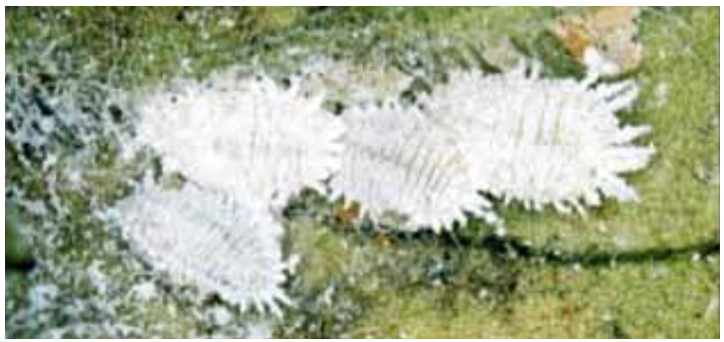

Figure 2.1: Adult mealybug

## 2.4.5 Symptoms of CSSVD

Manifestation of CSSV symptoms might include the presence of leaf indications as well as the development of swellings on both stems and roots (Jeger et al., 2003). The occurrence of red vein banding in leaves may be attributed to the elevation of anthocyanin levels along the veins and veinlets (Posnette, 1947). Subsequently, an anomalous pigmentation of the plant tissue ensues, characterized by an incomplete synthesis of chlorophyll, which may extend along prominent veins, manifesting as angular specks. Stem swellings have the potential to manifest at several locations throughout the plant, including the nodes, internodes, and roots. One prominent indication shown by the cocoa pod is a change in its shape, whereby the cocoa pods assume a more rounded form and, in some instances, approach a near-spherical appearance (Figure 2.2). Cocoa pods that are afflicted with disease have characteristics such as reduced size and a more uniform surface texture when compared to their healthy counterparts. Certain CSSV variants induce solely leaf symptoms, while others result in stem and root problems with little leaf manifestations. Additionally, there are CSSV variants that exhibit both types of symptoms (ICCO, 2015). In some cases, the manifestation of leaf symptoms is transient. In contrast, in other cases, afflicted cocoa pods may exhibit severe symptoms that have the potential to result in the demise of the cocoa plant.

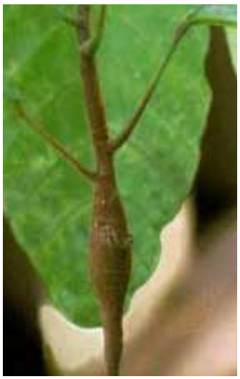

Figure 2.2: Swelling of shoots

## 2.4.6 Detection and control of CSSVD

At present, the identification of Cocoa Swollen Shoot Virus (CSSV) in agricultural settings involves the manual examination of cocoa plants by trained individuals to observe the presence of stem swelling and leaf symptoms (Jeger et al., 2003). Subsequently, cocoa trees afflicted with the disease are duly identified and appropriately marked prior to their removal, along with adjacent cocoa plants that have come into touch with them. The primary control method has been founded on a "zero tolerance" ideology, necessitating the removal of all affected trees and those in close proximity (Ameyaw et al., 2014). Consequently, there has been a significant depletion of tree populations, resulting in the demise of millions of trees while concurrently seeing a fast spread of infections among newly established farms. The rural population's perception of a governing party may be negatively affected by the significant decline in cocoa output due to tree damage, leading to high yearly losses (Lartey, 2013). Nevertheless, the complete elimination of the CSSV is exclusively financed by the government of Ghana, which entails a significant investment of national resources that might have otherwise been allocated to other facets of cocoa production (Anang et al., 2013).

## 2.4.7 Treatment of CSSVD in Ghana

Several studies on CSSVD have recognized the effectiveness of the eradication technique known as rouging in reducing the transmission of the disease (Adejumo, 2005; Dzahini-Obiatey et al., 2006; Hughes & Ollennu, 1994). Despite the labor-intensive nature of this procedure, it has been widely recognized in the literature as the most successful approach. Based on this information, a comprehensive countrywide initiative was initiated in 1941 to implement the process of rouging (Legg et al., 1984). The study conducted by Legg et al. (1984) focused on the identification and eradication of affected cocoa trees throughout a vast area spanning over 1.62 million hectares, including both forested regions and cocoa fields. In 1944, a systematic program was implemented with the objective of identifying and delineating instances of swollen shoot epidemics (Legg et al., 1984). This phenomenon persisted until the year 1946. Subsequently, a program was implemented in 1948 with the objective of providing education to farmers on the need to eliminate cocoa trees affected by the disease on their farms (Legg et al., 1984). The farmers were provided with incentives to engage in the process of reestablishing vegetation on the agricultural plots. In 1946, the Department of Agriculture was granted mandatory authority to eradicate cocoa plants that were afflicted, as documented by Legg et al. (1984). In order to enhance the collaboration among farmers, a system of compensation was implemented in 1948 (Legg et al., 1984). The introduction of monetary payment compensation for tree cutting and tree replanting was discussed by Legg et al. (1984). The farmers expressed dissatisfaction with the aforementioned government actions. The implementation of the rouging approach by the Government was greeted with significant opposition (Legg et al., 1984). The use of the rouging technique by cocoa growers led to an increase in political opposition against the colonial authority (Beckman, 1976). To this day, a considerable number of farmers persist in expressing their opposition towards the rouging method as a means of controlling the CSSVD. Ollennu et al. (1989) recommended the persistent use of a systematic strategy to delineate the regions affected by CSSVD accurately. The process of mapping should be complemented by a concerted effort to eliminate identified outbreaks swiftly. The authors issued a warning that any relaxation of these measures will lead to the disruption of the CSSVD control program. The attainment of this objective is contingent upon the identification and implementation of a more practical approach to address the issue of resistance from farmers (Dzahini-Obiatey et al., 2006).

## 2.4.8 Environmental factors affecting cocoa production and the spread of CSSVD

The environment significantly influences the development, growth, and production of cocoa. Rainfall, temperature, sun radiation, humidity, and soil are environmental elements that exert influence on cocoa production and disease transmission.

### 2.4.8.1 Rainfall

Cacao has a high vulnerability to drought conditions, and the cropping patterns of cacao are closely associated with the distribution of rainfall. Previous studies have found noteworthy associations between cacao output and precipitation levels over different time periods leading up to the harvest. Asante et al. (2017) have shown that in Ghana, there exists a pattern where a year characterized by heavy rainfall is subsequently accompanied by a year of abundant agricultural yield. However, it is important to note that this association does not hold true for all years. The study conducted by Adiku et al. (1997) revealed the existence of both positive and negative associations between rainfall patterns during certain months and the agricultural production of the primary crop in Ghana. The determination of soil moisture thresholds for cacao cultivation during the dry season in Ghana is subject to variability and contingent upon various factors encountered in field conditions. These factors encompass shade, air circulation, soil texture, and structure, as well as the age and vitality of the cacao tree. Additionally, the volume and distribution of active roots, along with root depth, contribute to the complexity of establishing these values. When evaluating the appropriateness of soil for cacao cultivation with respect to soil moisture, the crucial factor is not the absolute amount of soil moisture that is present but rather the speed at which the available water is released from the soil to the cacao tree (Ahenkorah, 1981).

### 2.4.8.2 Temperature

Temperature is well recognized as a critical meteorological variable that has a significant influence on the host, the pathogen, and the spread of disease (Tarr, 1972). With the development of instrumentation, extremely critical studies have been made on the effect of temperature on plant disease. According to Dimock (1967), temperature has been identified as the environmental component that can be measured, characterized, and controlled with the greatest ease and accuracy. The manipulation of temperature as a means of mitigating the occurrence of specific diseases, particularly in temperate areas, has been utilized by intentionally adjusting the timing of sowing to coincide with warmer conditions that are detrimental to the pathogen (Tarr, 1972). cacao, a tropical crop, has profitable growth potential within a temperature range of 30-32oC mean maximum, 18-21oC mean minimum, and an absolute low of 10oC (Wood & Lass, 2008). The relationship between temperature and light-use efficiency has been established, indicating that temperatures below 24oC result in a decline in the rate of light-saturated photosynthesis (Zhou et al., 2022). The photosynthetic rate has significant inhibition when temperatures drop below 10oC. The aperture of stomata in cooled leaves has a narrower opening compared to the aperture of stomata in non-chilled plants. Therefore, the resistance of stomata is influenced by leaf temperature, wherein higher temperatures lead to a reduction in resistance. Nevertheless, it is worth noting that the correlation between temperature rises and more significant vapour pressure deficits (VPD) suggests that the impact of VPD could supersede the influence of temperature (Muhammad & Hardwick, 1986). According to Buxton (2018), there is a correlation seen in Ghana between the time of elevated temperatures, characterized by the most significant disparity between maximum and lowest temperatures, and the occurrence of flushing.

### 2.4.8.3 Humidity

The significance of atmospheric moisture in host-parasite interactions is second only to that of temperature (Dimock, 1967). The association between humidity and the occurrence of diseases has been investigated by several researchers (Café-Filho et al., 2019; Perera, 1972; Schnathorst, 1965). In regions located in the tropics, characterized by relatively stable air temperatures throughout the year, the primary seasons are classified as wet and dry. Consequently, the timing and length of rainfall assume significant importance in these areas. In the region of Ceylon, the occurrence of illnesses caused by Phytophthora spp. on Hevea trees is strongly linked to prolonged periods of uninterrupted precipitation. The presence of rainfall in the form of atmospheric moisture, has a significant role in the mitigation of diseases. The presence of persistent precipitation not only facilitates the proliferation of diseases but also impedes the implementation of suitable management strategies (Ofori et al., 2022). In regions where cacao is cultivated, the relative humidity exhibits a consistent pattern, with nocturnal levels often reaching 100% and declining to 70-80% during daylight hours. In some instances, particularly during the dry season, the relative humidity may drop further. The primary impact of this phenomenon is seen in the expansion and development of leaf surface area (SantosaA et al., 2018). Plants cultivated under low humidity conditions (50-60%) have an increased leaf size and bigger leaf area compared to plants grown under medium (70-80%) and high (90-95%) humidity levels (SantosaA et al., 2018). Under the aforementioned circumstances, the leaves exhibit reduced size and a tendency to curl and wither at the apex. Additional consequences associated with elevated humidity levels include the proliferation of fungal ailments and challenges pertaining to the desiccation and preservation of the beans (SantosaA et al., 2018). The appropriateness of a location for cacao cultivation and the total crop yield are contingent upon the diversity of climatic variables.

### 2.4.8.4 Soils

Cacao cultivation encompasses a diverse array of soil types, with varying criteria for soil suitability. Cacao plants have a higher susceptibility to moisture stress compared to several other tropical crops. Furthermore, it has been shown that cocoa plants exhibit sensitivity to water-logging (Anim-Kwapong & Frimpong, 2004). Although they possess the ability to endure floods, they are unable to handle stagnant and water-logged environments. According to ICCO (2016), the minimum soil depth required to sustain cocoa cultivation is 1.5 meters. Forest soil that is rich in humus is considered the most suitable kind of soil for cultivating cocoa. Appropriate soil conditions facilitate the unhindered growth of plant roots, possess the ability to retain moisture in times of drought and facilitate the movement of air and moisture. Clay and sandy loams have been identified as appropriate soil types (Hartemink, 2005). An optimal condition for cultivating cacao involves a minimum organic matter content of 3.5%, with around 2% carbon concentration within the uppermost 15 cm of soil (Asante et al., 2021). Cacao exhibits optimal growth in soil environments characterized by a pH range of 6 to 7.5, which facilitates the availability of essential nutrients and trace elements (Asigbaase et al., 2021). The analysis and evaluation of soils appropriate for cocoa cultivation reveal that the predominant physical qualities of favorable cacao soils are deep, easily crumbled loam to clay loam, as well as sandy loam soils. The soil profiles exhibit a notable feature of having a relatively low cation exchange capacity. According to Buxton (2018), there is a notable concentration of nitrogen content within the uppermost 10 cm layer, with a significant reduction in subsequent layers below this threshold. Adu and Mensah-Ansah (1969) conducted a categorization of soils in Ghana, distinguishing between soils ideal for cacao cultivation and those that are unsuitable. This categorization was based on examinations of soil texture and depth. A desirable cacao soil profile often exhibits a substantial depth and is distinguished by a well-drained upper layer devoid of gravel situated above a sandy clay loam stratum. This stratum commonly has iron oxide concretions and quartz gravels. The aforementioned stratum is situated above a deposit of stationary variegated clay, which gradually transitions into the somewhat weathered parent material (Ahenkorah, 1981). The soils that are considered inappropriate are characterized by a high degree of desaturation and are predominantly composed of ferritic soils, namely Forest Oxysols and Oxysol-Ochrosol intergrades. The soils in question are found throughout the southern portion of the Western Region. The expansion of cocoa cultivation in recent years has occurred largely in these particular soil types. The absence of fertilizer application leads to insufficient mineral availability, resulting in reduced crop productivity and accelerated tree senescence. the productivity of trees cultivated under optimal sunshine conditions often experiences a decline starting from around the tenth year (Ahenkorah, 1981). The appropriate types of soils for this purpose are somewhat de-saturated ferritic soils, namely dystropepts or Forest Ochrosols. The species in question is mainly located within the historical cocoa cultivation regions of the Eastern and Ashanti Regions. It has been shown that it is feasible to attain potential yields of around 1500 kg per hectare over a span of fifteen years, even in the absence of fertilizer administration and under the influence of mild and consistent shading conditions (Ahenkorah, 1981). The soils that are most appropriate for this purpose are the slightly de-saturated ferritic soils, namely the tropical eutrophic brown soils and the Forest Ochrosol - Rubrisol intergrade. These soils possess a high exchange capacity. These soil types have enhanced responsiveness to mineral fertilizers. The soils in question are often characterized by good drainage and a significant depth. They are found in certain restricted regions within Ashanti and the northern part of the Western region, as documented by Ahenkorah (1981).

# 2.5 Geographic Information System

A geographic information system (GIS) is a theoretical framework that facilitates the acquisition and examination of spatial and geographical data. Geographic Information System (GIS) applications, often known as GIS apps, are computerized instruments that enable users to generate interactive queries, manipulate and modify spatial and non-spatial data, examine the output of geographic information analysis, and graphically communicate the outcomes of these processes via map representations.

A geographic information system (GIS) refers to a computer-based system designed to acquire, store, validate, and visualize data pertaining to spatial locations on the Earth's surface. Geographic Information Systems (GIS) have the capability to display a diverse range of data types simultaneously on a single map, including but not limited to roadway networks, building structures, and plant cover (Goodchild, 2004). This facilitates enhanced visibility, analysis, and comprehension of patterns and trends. The advantages include enhanced communication and efficiency, with increased management and decision-making capabilities (Goodchild, 2004). Geographic Information Systems (GIS) enable the comparison and contrast of many forms of information. The system has the capability to include several types of data pertaining to demographic statistics, income levels, and educational attainment. The report may include details pertaining to the geographical features, including the precise positioning of watercourses, diverse flora species, and various soil compositions. The information may include many locations such as industries, farms, and schools, as well as storm drains, highways, and electric power lines.

The use of Geographic Information Systems (GIS) enables individuals to conduct comparative analyses of various spatial entities, hence facilitating the identification and understanding of their interrelationships. For instance, by using Geographic Information Systems (GIS), it becomes possible to integrate diverse data sets into a single map, including both pollution-emitting facilities like factories and environmentally vulnerable areas such as wetlands and rivers. The use of such a map would enable individuals to assess the areas where water resources are most vulnerable (Goodchild & Haining, 2004).

## 2.5.1 GIS Methods for Mapping Plant Epidemiology

Geographical Information System (GIS) is a powerful tool used in various fields to analyze and visualize spatial data. In the context of plant epidemiology, GIS plays a crucial role in mapping the distribution and spread of plant diseases and pests. By integrating spatial data with other information such as climate, soil conditions, and crop management practices, GIS enables researchers and practitioners to gain valuable insights into the dynamics of plant epidemics and make informed decisions for disease management. In this article, we will explore the different GIS methods used for mapping plant epidemiology.

### 2.5.1.1 Spatial Data Acquisition

The first step in mapping plant epidemiology using GIS is the acquisition of spatial data. This includes collecting information on the location and extent of disease outbreaks, as well as relevant environmental data. There are several methods for acquiring spatial data, including remote sensing, GPS (Global Positioning System), and field surveys. Remote sensing techniques, such as satellite imagery and aerial photography, can provide high-resolution data on vegetation health and disease patterns over large areas. GPS technology allows researchers to collect precise location data in the field, while field surveys involve manual collection of data on disease incidence and severity.

### 2.5.1.2 Data Preprocessing and Integration

Once the spatial data is acquired, it needs to be preprocessed and integrated with other relevant datasets. This involves data cleaning, georeferencing, and spatial interpolation. Data cleaning ensures that the acquired data is free from errors and inconsistencies. Georeferencing involves assigning spatial coordinates to the data so that it can be accurately represented on a map. Spatial interpolation techniques are used to estimate values at unsampled locations based on the available data, which helps in creating continuous surfaces of disease distribution.

### 2.5.1.3 Spatial Analysis

Spatial analysis is a key component of GIS and involves analyzing the relationships between different spatial entities. In the context of plant epidemiology, spatial analysis techniques are used to identify disease hotspots, assess the spread patterns, and detect spatial clusters of infected plants. Some commonly used spatial analysis methods include spatial autocorrelation analysis, kernel density estimation, and cluster analysis. Spatial autocorrelation analysis measures the degree of similarity or dissimilarity between spatial entities and helps identify areas with similar disease patterns. Kernel density estimation is used to create density surfaces, which highlight areas with high disease occurrence. Cluster analysis identifies clusters of infected plants and helps understand the spatial dynamics of disease spread.

Yankson et al. (2019) analyzed and mapped the malaria risk in children under 5 years old, with the goal of identifying areas where control efforts could be targeted. The study utilized data collected from the 2016 Ghana Demographic and Health Survey to analyze and map malaria risk in children under 5 years old. Geostatistical methods were employed to analyze the prevalence data and explore the spatial distribution of malaria risk. The results of the analysis provided valuable insights into the areas with a higher risk of malaria in Ghana, which can aid in targeting control efforts and allocating resources effectively. The study highlighted the importance of geographically targeted interventions and the need for up-to-date maps showing the spatial distribution of malaria.

Ejigu (2020) designed an effective intervention mechanism for malaria by creating an up-to-date map that depicts the spatial distribution of malaria in Mozambique. The research utilized the 2018 Mozambique Malaria Indicator Survey and employed geostatistical methods to analyze the data. The study aimed to explore the determinants of malaria at the individual, household, and community levels in under-five children, develop a malaria prevalence map for Mozambique, and generate prediction prevalence maps and exceedance probability. The study's findings contribute to the understanding of malaria risk factors in Mozambique and provide valuable information for designing targeted interventions to combat the disease. By mapping the spatial distribution of malaria, researchers and public health authorities can better identify high-risk areas and allocate resources more effectively for prevention and control measures.

Noé et al. (2018) focused on understanding the distribution and persistence of malaria hotspots in Bangladesh over a four-year period, from 2013 to 2016. The study aimed to address the challenges hindering malaria elimination in the southeast Asian region, such as anti-malarial resistance and underreporting. By mapping and analyzing the spatial epidemiology of malaria, the researchers identified hotspots with higher malaria incidence rates. The study utilized Geographic Information Systems (GIS) and cartography to visualize the hotspots and determine their stability over time. The findings of this study can provide valuable insights for targeting interventions and allocating resources effectively to combat malaria in Bangladesh. Overall, this study contributed to the understanding of malaria dynamics and the identification of high-risk areas in Bangladesh, facilitating evidence-based decision-making for malaria control and elimination efforts

### 2.5.1.4 Species Distribution Modeling

Species distribution modeling (SDM) is a GIS method that uses environmental variables to predict the potential distribution of a species or disease. In the context of plant epidemiology, SDM can be used to map the suitable habitat for a particular pathogen or vector. This information is valuable for predicting the future spread of diseases and identifying areas at high risk. SDM techniques, such as MaxEnt (Maximum Entropy), Random Forest, and Generalized Linear Models, are commonly employed to model the distribution of plant pathogens based on environmental variables such as temperature, humidity, and land cover.

Beck-Johnson et al. (2013) investigated how temperature influences the life cycle, development, survival, and reproduction of Anopheles mosquitoes, which are known vectors for transmitting the malaria parasite. The researchers conducted field observations and laboratory experiments to analyze the relationship between temperature and the various stages of the mosquito's life cycle, including egg hatching, larval development, pupal stage, and adult longevity. They also examined the effects of temperature on the mosquito's feeding habits, biting rate, and ability to transmit the malaria parasite. The findings of the study revealed that temperature plays a crucial role in shaping the population dynamics of Anopheles mosquitoes. Higher temperatures were found to accelerate the development of the mosquitoes and increase their survival rates, leading to larger populations. The study also found that warmer temperatures influenced the biting behavior of the mosquitoes, increasing their feeding frequency and the likelihood of malaria transmission to humans. The comprehensive analysis of temperature's influence on Anopheles mosquito population dynamics and malaria transmission provided valuable insights into the potential effects of climate change on the spread of malaria. The findings underscore the importance of considering temperature variations when assessing the risk of malaria transmission in different geographic regions and anticipating future changes in disease patterns.

Gomez-Elipe et al. (2007) investigated the use of historical data on monthly case reports, as well as environmental factors to forecast malaria incidence in the Karuzi region of Burundi between the years 1997 and 2003. The environmental factors included NDVI, rainfall, and temperature. By analyzing the relationship between historical case reports and environmental variables, the researchers used the Auto Regressive Integrated Moving Average (ARIMA) algorithm to predict future malaria incidence. The model was able to capture the complex interactions between environmental factors and the transmission dynamics of malaria.

Kleinschmidt et al. (2000) discussed the importance of accurate malaria risk maps for effective malaria control. Mapping malaria risk requires modeling to predict the risk across the entire area, but actual malaria prevalence data is often limited to specific locations. The challenge lies in accounting for local variations in risk that cannot be explained by known factors and the uneven distribution of malaria prevalence data points. Environmental and climatic variables such as rainfall, NDVI, temperature, and proximity to water body was considered by the authors. The authors presented a simple two-stage procedure for producing maps of predicted risk. The authors used logistic regression modeling and kriging to estimate the risk and address the issue of unaccounted local variations. The procedure involves determining appropriate covariates and applying spatial statistical techniques to create comprehensive risk maps. In the wet season (June-November), the mean NDVI was calculated, while the mean maximum temperature from March to May was determined. The significant independent variables for predicting malaria prevalence were identified as months with rainfall exceeding 60 mm and the distance to water bodies.

Gemperli et al. (2006) proposed the use of transmission models, specifically the Garki model, to address these limitations and achieve comparability between different surveys. The authors suggested converting heterogeneous age prevalence data from prevalence surveys into a common scale of estimated entomological inoculation rates, vectorial capacity, or force of infection. This approach was applied to survey data from Mali, collected between 1965 and 1998, which were extracted from the Mapping Malaria Risk in Africa database. NDVI derived from Advanced Very High-Resolution Radiometer (AVHRR) was used together with climatic and environmental variables such as temperature, length of rainy season, and proximity to water source. It was discovered that the rainy season did not have much of an impact on the entomological inoculation rate (EIR), nor on the NDVI or temperature. However, there was a strong correlation between transmission intensity and the distance to water. According to their data, areas within 4 km of a water source are more likely to experience high transmission rates. This information could be crucial in planning and implementing effective measures to control the spread of diseases related to mosquito-borne illnesses.

Lartey (2013) mapped the distribution of CSSVD in the Western Region of Ghana. The author selected historical rainfall data, temperature, elevation, slope, aspect, and distance to forest areas as the key environmental variables for CSSVD transmission. The MaXent algorithm was used to map the location of CSSVD occurrences. It was revealed that 33.5% of cocoa farms within the study is infected with CSSVD and rainfall, temperature, elevation, aspect, and distance to forest areas correlate to the occurrence of the disease while slope had minimal relationship with the disease occurrence.

### 2.5.1.5 Risk Mapping

Risk mapping involves assessing the vulnerability and potential impact of plant diseases on agricultural systems. GIS-based risk mapping takes into account various factors such as disease prevalence, host susceptibility, and environmental conditions to generate risk maps. These maps help stakeholders prioritize surveillance efforts, allocate resources for disease management, and develop targeted control strategies. Risk mapping can also incorporate socio-economic factors, such as crop value and market access, to estimate the economic impact of plant diseases on different regions.

Gosoniu et al. (2009) analyzed the prevalence of malaria in West Africa to produce regional parasitemia risk maps. The study recognized that the climate-malaria relation and spatial correlation in malaria transmission can vary across different agro-ecological zones, introducing non-stationarity. The researchers developed a non-stationary geostatistical model to account for these variations and used malaria prevalence data from the "Mapping Malaria Risk in Africa" database. By employing a Bayesian nonparametric non-stationary approach, the study aimed to capture the complex and nonlinear relationship between malaria transmission and environmental/climatic factors. The analysis considered spatially structured covariates, including both environmental and human-made factors, to understand their influence on malaria transmission. The ultimate goal was to create accurate risk maps to guide malaria control interventions and resource allocation. This study contributes to the broader efforts in understanding and combating malaria in West Africa. By utilizing advanced statistical modeling techniques and considering the spatial and non-linear nature of malaria transmission, it provides valuable insights into the factors influencing the prevalence of malaria in the region. The risk maps generated from this study can assist policymakers and health organizations in effectively targeting malaria control measures in specific areas of West Africa.

### 2.5.1.6 Decision Support Systems

GIS-based decision support systems (DSS) provide tools and models that assist in decision-making for disease management. These systems integrate spatial data with models for disease spread, crop growth, and economic analysis to provide recommendations on optimal disease control strategies. DSS can consider factors such as crop rotation, pesticide application, and resistant cultivars to suggest the most effective and sustainable management practices. By simulating different scenarios and evaluating their potential outcomes, DSS can help policymakers and growers make informed decisions to minimize disease risks and optimize resource allocation.

Arab et al. (2014) investigated the relationship between climate factors and malaria incidence in West Africa. The study utilizes a hierarchical Bayesian modeling framework to analyze malaria and climate data from ten West African countries, including Benin, Burkina Faso, Côte d'Ivoire, Gambia, Ghana, Liberia, Mali, Senegal, Sierra Leone, and Togo, during the period from 1996 to 2006. The research aimed to understand how climate variability impacts the distribution of malaria in this region. The research findings contribute to the understanding of the complex dynamics between climate and malaria transmission. The study presents a comprehensive analysis of the effects of weather and climate on malaria distribution in West Africa, taking into account the hierarchical nature of the data and the spatial and temporal dependencies. These findings may aid in the development of more effective strategies for malaria control and prevention in the region.

### 2.5.1.7 Web-based Mapping and Visualization

Web-based mapping and visualization platforms have gained popularity in recent years, allowing stakeholders to access and interact with spatial data through web browsers. These platforms enable the dissemination of disease maps, real-time monitoring of disease outbreaks, and collaborative data sharing among researchers and practitioners. Web-based GIS applications also facilitate the integration of different data sources, such as weather data and disease surveillance data, to provide a comprehensive view of plant epidemiology. Interactive maps and visualizations enhance the accessibility and usability of spatial information, enabling users to explore and analyze the data more effectively.

Aheto (2022) studied the issue of under-five child malaria in Ghana. The study aimed to provide opportunities for efficient malaria surveillance and targeted control efforts in the face of limited public health resources. The researchers produced high-resolution interactive web-based spatial maps to characterize geographical differences in malaria risk and identify high burden communities. The study utilized data from the 2019 Malaria Indicators Survey (MIS) of the Demographic and Health Survey Program. The results of this research contribute to the understanding of malaria risk factors in Ghana and provide valuable information for malaria prevention and control efforts in the country.

Grover-Kopec et al. (2005) emphasized the significance of rainfall monitoring as a crucial component of early warning systems for epidemic malaria in Africa. The study highlighted the need to predict malaria outbreaks and improve prevention strategies through timely vector control and drug deployment. The study focused on the development and utilization of an online operational rainfall-monitoring resource to enhance epidemic malaria early warning systems in Africa. By leveraging these tools, decision-makers and stakeholders can improve preparedness, response, and prevention strategies for malaria outbreaks in sub-Saharan Africa.

# 2.6 Remote Sensing and Its Applications

Remote sensing is a powerful technology that enables the acquisition of detailed information about the Earth's surface using sensors mounted on satellites, aircraft, or drones. In the context of plant epidemiology, remote sensing plays a vital role in mapping and monitoring the spatial distribution of plant diseases, pests, and other environmental factors that influence disease dynamics. Remote sensing datasets provide valuable information on vegetation health, land cover, climate, and other variables that are essential for understanding and managing plant epidemics. An attempt is made to review the different types of remote sensing datasets used for mapping plant epidemiology.

## 2.6.1 Multispectral Imagery

Multispectral imagery is one of the most commonly used remote sensing datasets for mapping plant epidemiology. It consists of data collected from sensors that measure the reflectance of different wavelengths of light, typically divided into several discrete bands. These bands capture information about the spectral characteristics of vegetation, which can be used to assess plant health and identify areas affected by diseases or pests. Multispectral datasets such as Landsat, Sentinel-2, and Moderate-resolution Imaging Spectrometer (MODIS) provide frequent and consistent coverage of large areas, allowing for long-term monitoring and analysis of disease patterns. Raso et al. (2009), Giardina et al. (2012), and Raso et al. (2012) used MODIS as a source of remote sensing data to derive environmental data such as NDVI to aid in malaria-parasite related research. Several researchers have also made use of the Meteosat 7, ASTER, AVHRR and Landsat 7 ETM+ in carrying out epidemiological research (Cohen et al., 2013; Gemperli et al., 2006; Gosoniu et al., 2006; Kleinschmidt et al., 2000; Nygren et al., 2014).

## 2.6.2 Hyperspectral Imagery

Hyperspectral imagery offers a higher level of spectral resolution compared to multispectral imagery. It measures the reflectance of a much larger number of narrow and contiguous spectral bands, resulting in a more detailed characterization of the Earth's surface. Hyperspectral datasets provide information on subtle variations in vegetation properties, such as biochemical composition, stress levels, and disease symptoms. These datasets enable the detection and discrimination of specific plant diseases based on their unique spectral signatures. However, hyperspectral imagery is typically more expensive to acquire and process compared to multispectral imagery.

## 2.6.3 Thermal Imagery

Thermal imagery measures the emitted or reflected heat energy from the Earth's surface. It provides information on surface temperature, which is closely related to plant health and disease occurrence. Changes in temperature can indicate stress or infection in plants, as pathogens often affect the physiological processes and water uptake of the host. Thermal remote sensing datasets, such as those obtained from thermal infrared sensors, can be used to identify areas with abnormal temperature patterns associated with disease outbreaks. Additionally, thermal imagery can help assess the impact of environmental factors, such as temperature gradients and microclimatic conditions, on disease development and spread.

## 2.6.4 LiDAR Data

Light Detection and Ranging (LiDAR) is a remote sensing technique that uses laser pulses to measure the distance between the sensor and the Earth's surface. LiDAR data provides detailed information on the three-dimensional structure of vegetation, including canopy height, biomass, and structural complexity. These attributes are crucial for understanding disease dynamics, as they influence the microclimate, host susceptibility, and pathogen dispersal within plant communities. LiDAR datasets are particularly valuable for mapping diseases that affect tree canopies, such as fungal pathogens and insect infestations. Combined with other remote sensing datasets, LiDAR data enhances the accuracy of disease mapping and helps identify areas at high risk.

## 2.6.5 Radar Imagery

Radar remote sensing uses microwave signals to measure the backscattered energy from the Earth's surface. Radar datasets provide unique capabilities for mapping plant epidemiology, as they are sensitive to vegetation structure, moisture content, and surface roughness. Radar imagery can penetrate clouds and provide data regardless of weather conditions, making it suitable for continuous monitoring of disease dynamics. Synthetic Aperture Radar (SAR) data, in particular, has been used to detect changes in vegetation structure, identify areas affected by diseases or pests, and assess the impact of environmental factors on disease spread. SAR datasets are available from satellite sensors such as Sentinel-1 and RADARSAT.

## 2.6.7 Unmanned Aerial Vehicle (UAV) Imagery

Unmanned Aerial Vehicles (UAVs) equipped with remote sensing sensors offer great flexibility and high-resolution data acquisition capabilities. UAV imagery allows researchers to obtain detailed spatial information at a fine scale, which is particularly valuable for mapping plant diseases in small-scale agricultural fields or orchards. UAV-based remote sensing datasets, including multispectral, thermal, and hyperspectral imagery, can provide high-resolution and near-real-time information on plant health, disease severity, and distribution. The rapid data acquisition and processing capabilities of UAVs enable timely and targeted disease management interventions.

## 2.6.8 Integration of Remote Sensing Datasets

To achieve a comprehensive understanding of plant epidemiology, it is often necessary to integrate multiple remote sensing datasets. The integration of different datasets allows for the analysis of complex interactions between vegetation health, environmental conditions, and disease dynamics. For example, combining multispectral imagery with thermal data can provide insights into the relationship between plant stress, temperature patterns, and disease occurrence. Similarly, the integration of LiDAR data with multispectral or hyperspectral imagery can improve the accuracy of disease mapping by considering both the structural characteristics and spectral properties of vegetation.

# Chapter Three

# METHODOLOGY

## Study Area

### 3.1.1 Location And Characteristics

The study area was chosen as the Sefwi Akontombra and Dadiesoaba District in Ghana's Western North Region. Two study areas were chosen to understand the spatial patterns and trends of the CSSVD. Sefwi Akontombra is one of the new districts carved out of Ghana's old Western region, which was established in 2008. It's in the north-eastern corner of the Western Region, between latitudes 60N and 60 30'N and latitudes 20 45'W and 20 15'W. The district covers 1,120 square kilometers, accounting for 3% of the total land area of the Western North Region. Sefwi Wiawso Municipal and Juaboso District border it on the east, Aowin Municipal on the north, Amenfi West Municipal on the south, and Sefwi Wiawso Municipal and Juaboso District on the west. The district covers 1,120 square kilometers, accounting for 3% of the total land area of the Western North Region. It is roughly rectangular, with the district capital, Akontombra, almost on the far western edge.

The district that houses Dadiesoaba is located in the Brong Ahafo Region's western region. It is bordered on the north by Asutifi North District, on the east by Ahafo Ano North District, on the west by Asunafo Municipal, on the south by Atwima Mponua District, and on the south by Asunafo South District. The district's total land area is approximately 597, 244 square kilometers. The District is situated between 6°40' and 7°15' north latitude and 2°15' and 2°45' west longitude.

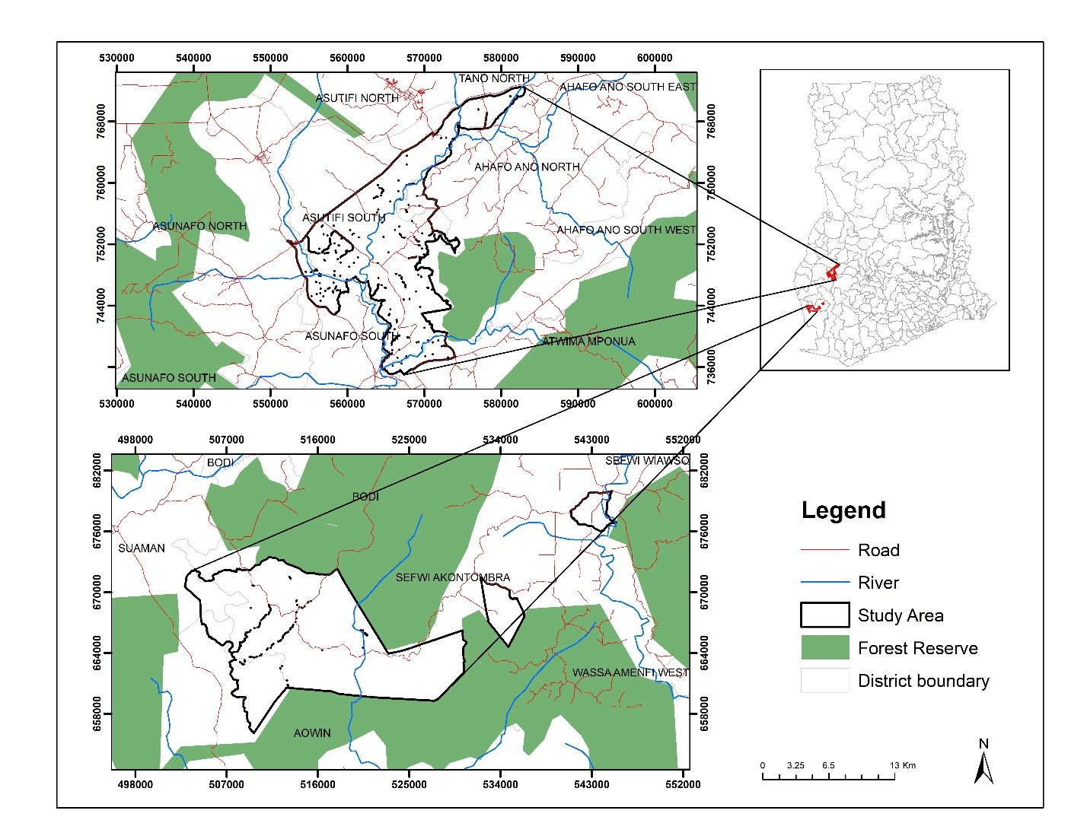

Figure 3.1 Map of study area

### 3.1.2 Topography

For Sefwi Akontombra, the Tano and Bia River Basin cuts through the east, which is primarily below 152.4m above sea level, and the majority of the district is undulating with elevations between 152.4m and 610m above mean sea level. The main drainage system is the Tano River and its tributaries. In La Cote d'Ivoire, the Tano River flows south and empties into the sea. The main tributaries are the Suhien, Kunuma, Sui, and Yoyo (Sefwi Akomtonbra District Assembly, 2015).

The Ahafo Ano South West District has a total surface area of about 1241 km sq., accounting for 5.8% of the total surface area of the region. The district can be said to be located within Ghana's forest belt, based on the above description of its location (*Asutifi South*, 2020).

Furthermore, the topography of Dadiesoaba is mostly undulating, with gentle slopes of less than 1%. In the south west, the land rises from 30m to over 61m above sea level, with some high elevations near Sienchiem and Nkrankrom (Dadiesoaba, 2019).

### 3.1.3 Climate

The Akontombra District is located in a tropical rainforest environment, with year-round temperatures ranging from 22.1 to 35 degrees Celsius and annual rainfall ranging from 1524 to 1780 millimeters, with the highest rainfall peaks occurring in June, July, September, and October. Humidity levels are relatively high, ranging from over 90% at night to around 75% during the day. (Sefwi Akomtonbra District Assembly, 2015).

Lastly, The Asutifi South District of Dadiesoaba is located in a wet semi-equatorial zone with double rainfall maximums. There are two seasons: the major season (April to July) and the minor season (August to October) (September to November). Crop farming, which is the district’s main occupation, thrives during the rainy season.

### 3.1.4 Vegetation Cover

The Sefwi Akontombra District is located in Ghana's wet semi-deciduous forest zone, which encompasses the majority of the Ashanti, Western, Brong-Ahafo, and Eastern Regions. Some species present in the Forest zone of the District are Onyina Odum, Wawa, Mahogany, Sapele, Emire, Asamfina and Red Cedar (Sefwi Akomtonbra District Assembly, 2015).

Alternatively, the Ahafo Ano South West district has arable land abounds. Around 80% of the land is suitable for crop cultivation, with approximately 60% of the arable land under cultivation. The main food crops grown are maize, rice, cassava, yam, cocoyam, and plantain.

Furthermore, the Asutifi South District of Dadiesoaba has a semi-deciduous forest as its dominant vegetation type. However, man's activities, such as farming, lumbering, and occasional bushfires, have caused this vegetation to be disturbed. As a result, some areas have been transformed into a desolate wooded savannah. Transitional zones like these can be found near Kensere and Dadiesoaba (Dadiesoaba, 2019).

### 3.1.5 Population and Economic Activities

The Akontombra district has a population of 109,868 people, with 56,085 men and 53,783 women, according to the 2010 population and housing census. The population density was 94.96 people per square kilometer between 2010 and 2020, with an annual population change of 2.9 percent. Around 86.5 percent of the working population is employed in skilled agriculture, forestry, and fishing, with 4.3 percent employed in service and sales, 3.6 percent in craft and allied trades, and 0.3 percent employed in clerical assistance.

Lastly, The District's population of Dadiesoaba is 53,584, with males accounting for 53.0 percent and females for 47.0 percent. The district has a young population, with children aged 5 to 9 accounting for 12.4 percent of the total population, 10-14 accounting for 12.1 percent, and 15-19 accounting for 10.8 percent. With 14.0 percent of the total population, the age group 0-4 had the highest percentage (Dadiesoaba, 2019).

# 3.2 Research Materials

## 3.2.1 Data

To accomplish the aim of the study, it was necessary to include both primary and secondary data (Table 3.1).

Table 3.1: Data sources used

|  |  |  |
| --- | --- | --- |
| **Data layers** | **Data format** | **Source** |
| Distance from Rivers | Vector | CHED |
| LULC | Raster | Copernicus |
| Rainfall | Raster | CHIRPS |
| Soil | Raster | FAO |
| CSSVD | Vector | CHED |
| Slope | Raster | NASA Earthdata |

The data were gathered from Ghanaian government agencies and augmented with other publicly accessible sources. The input elements used were selected by availability of the data, geographical dimensions, and processing capabilities. According to the research, several variables might affect the outbreak of CSSVD. However, only those variables for which data were available was used. All data were projected to the World Geodetic System 1984 (WGS 84) Universal Transverse Mercator (UTM) projection, Zone 30N, to ensure spatial consistency. The following datasets was gathered and analysed;

### 3.2.1.1 Digital Elevation Model

Advanced Spaceborne Thermal Emission and Reflection Radiometer (ASTER) Digital Elevation Model (DEM) was freely accessed from the Earthdata platform (<https://earthdata.nasa.gov/>). The 30-meter resolution DEM was processed using ESRI Spatial Analyst modules to extract slope (figure 3.2 and 3.3).

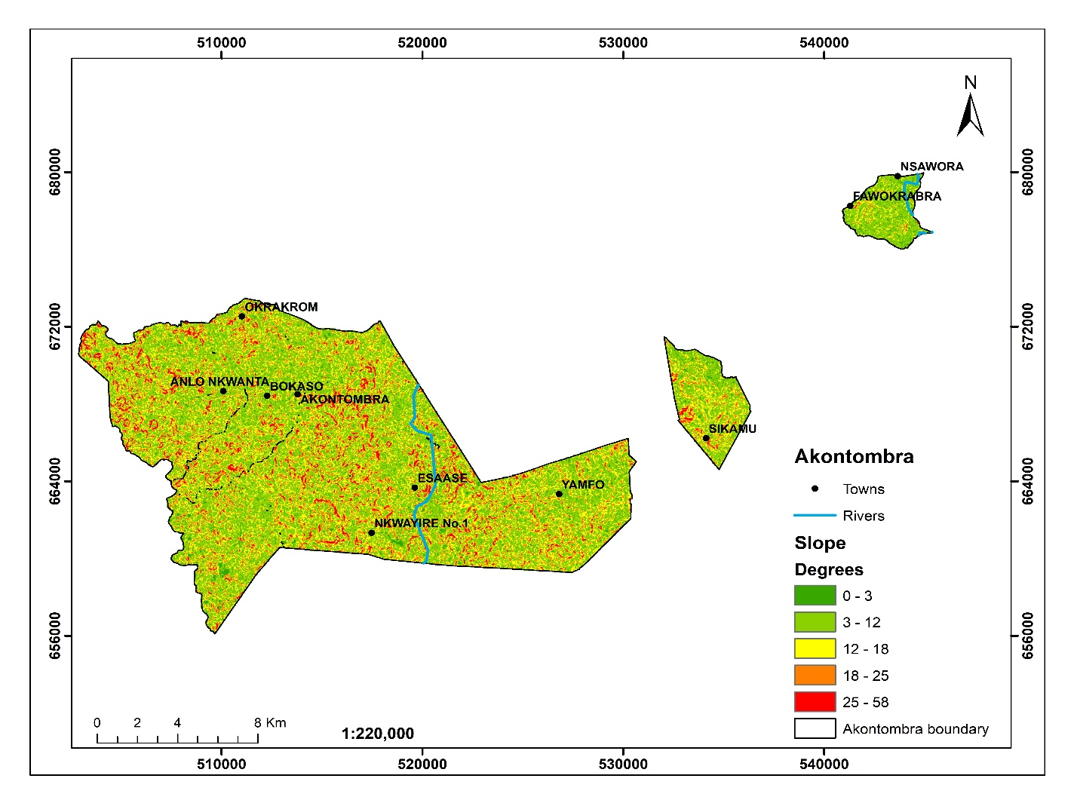

Figure 3.2 Slope map of Akontombra cocoa district

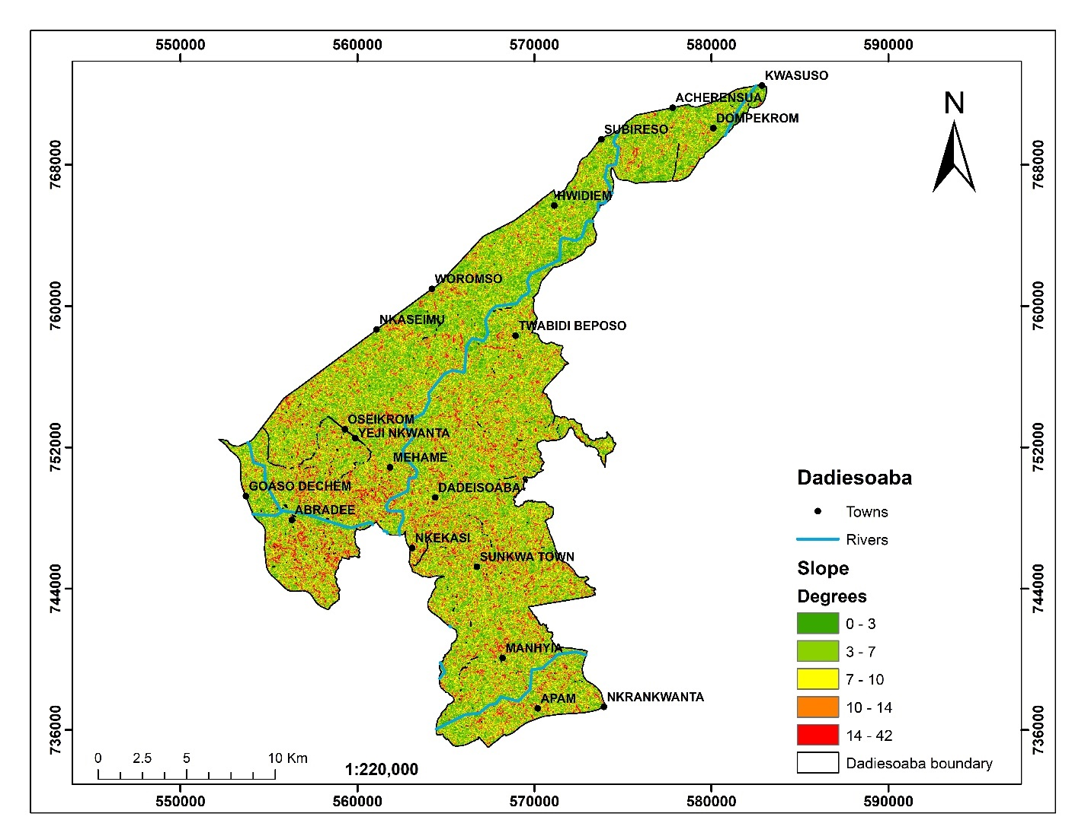

Figure 3.3 Slope map of Dadiesoaba cocoa district

### 3.2.1.2 Land Use/Land Cover

The land use/land cover layer for the Akontombra and Dadiesoaba cocoa district (figure 3.4 and 3.5) was obtained from the Copernicus Global Land Service (CGLS) platform (<https://lcviewer.vito.be/>). Copernicus produces a worldwide land cover map at 100 m spatial resolution. The principal land cover scheme is provided by the CGLS Land Cover package. In addition to these discrete classes, the product contains continuous field layers for all fundamental land cover classes that offer proportionate estimates of vegetation/ground cover for the land cover categories. This continuous categorization approach may more accurately reflect regions with varied land cover than the usual classification scheme (Buchhorn et al., 2020).

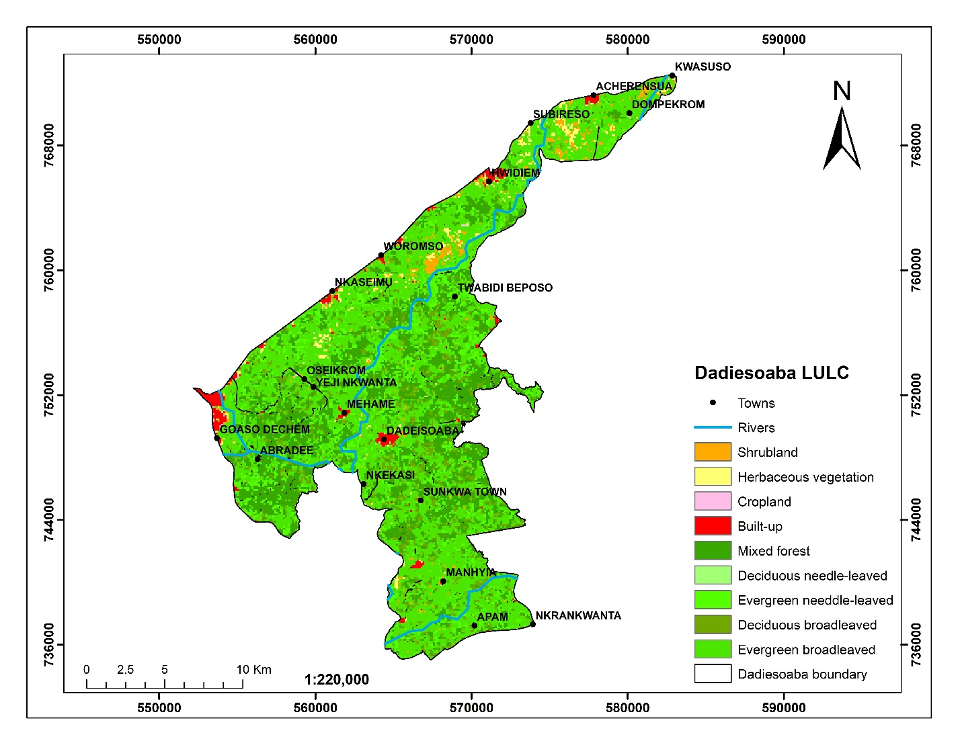

Figure 3.4 LULC map of Dadiesoaba cocoa district

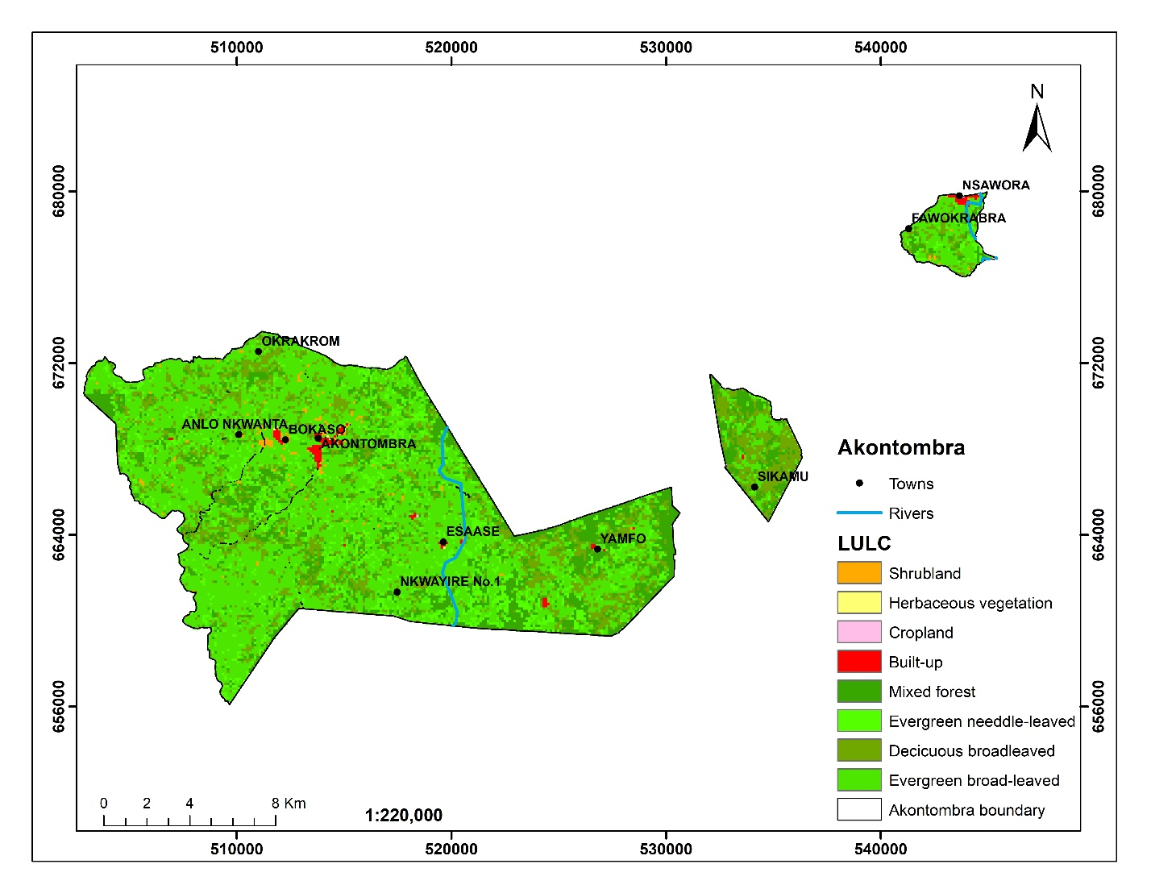

Figure 3.5 LULC map of Akontombra cocoa district

### 3.2.1.3 Soil

Soil data was freely accessed and downloaded from the Food and Agriculture Organization (FAO) soil hub (<https://www.fao.org/soils-portal/data-hub/soil-maps-and-databases/faounesco-soil-map-of-the-world/ru/>). Figure 3.6 and 3.7 shows the soil map of Dadiesoaba and Akontombra cocoa district, respectively.

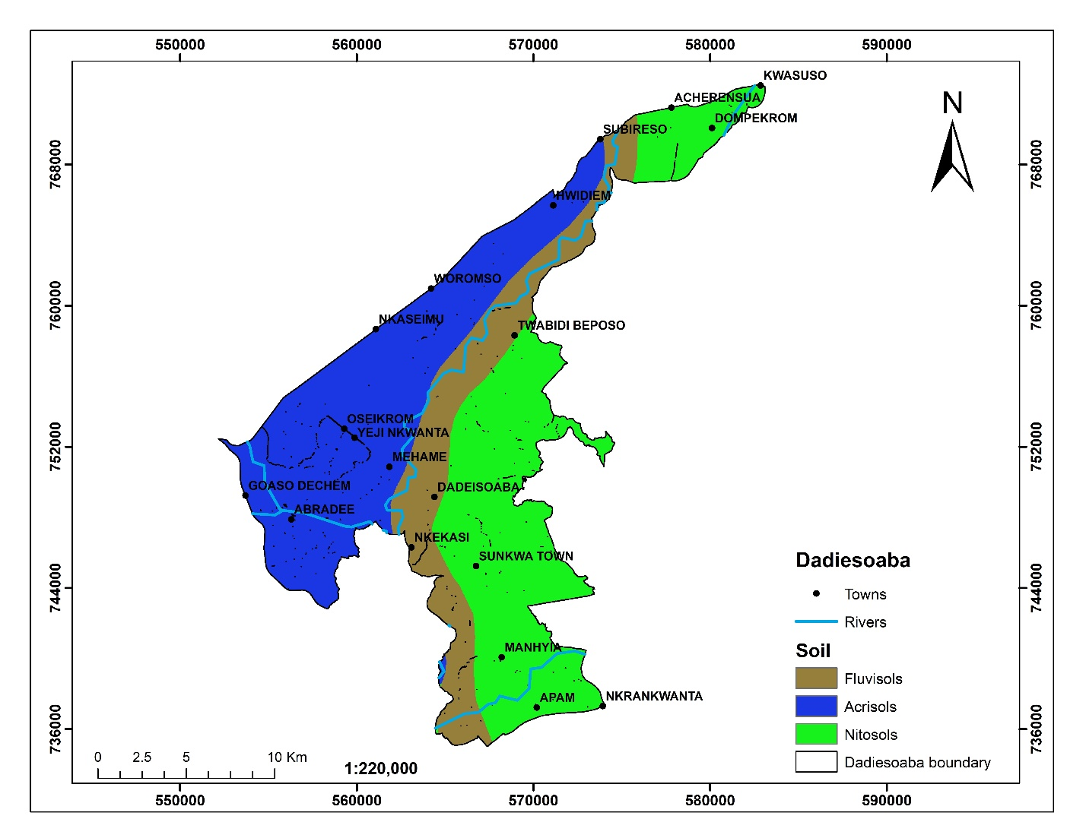

Figure 3.6 Soil map of Dadiesoaba cocoa district

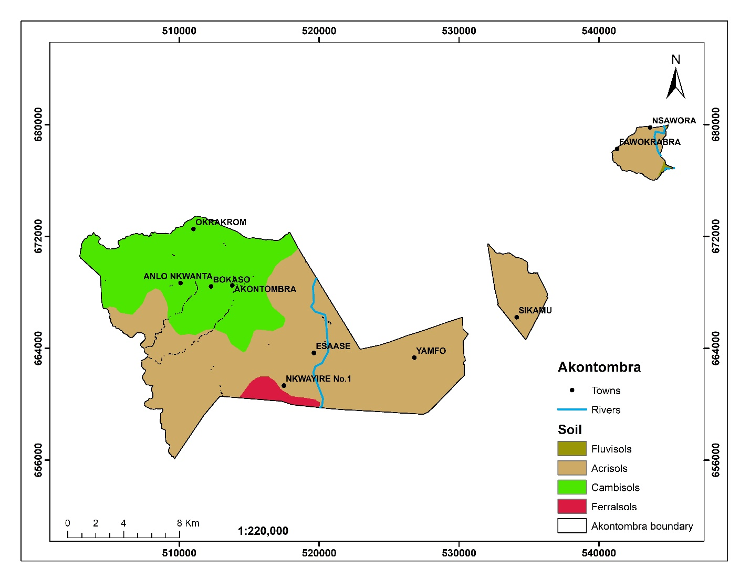

Figure 3.7 Soil map of Akontombra cocoa district

### 3.2.1.4 Rainfall

Rainfall data was obtained from the Climate Hazards Group InfraRed Precipitation with Station data (CHIRPS) portal (<https://chrsdata.eng.uci.edu/>). CHIRPS rainfall data when imported into ArcGIS 10.5 and clipped to the study area boundary had no values within some portions of the study area. The imported rainfall data was therefore converted to a vector format and interpolated to provide estimated rainfall values for all areas within the study area. The CHIRPS data is an annual precipitation sourced from rain gauge and satellite observations. Rainfall data used is shown in figure 3.8 and 3.9.

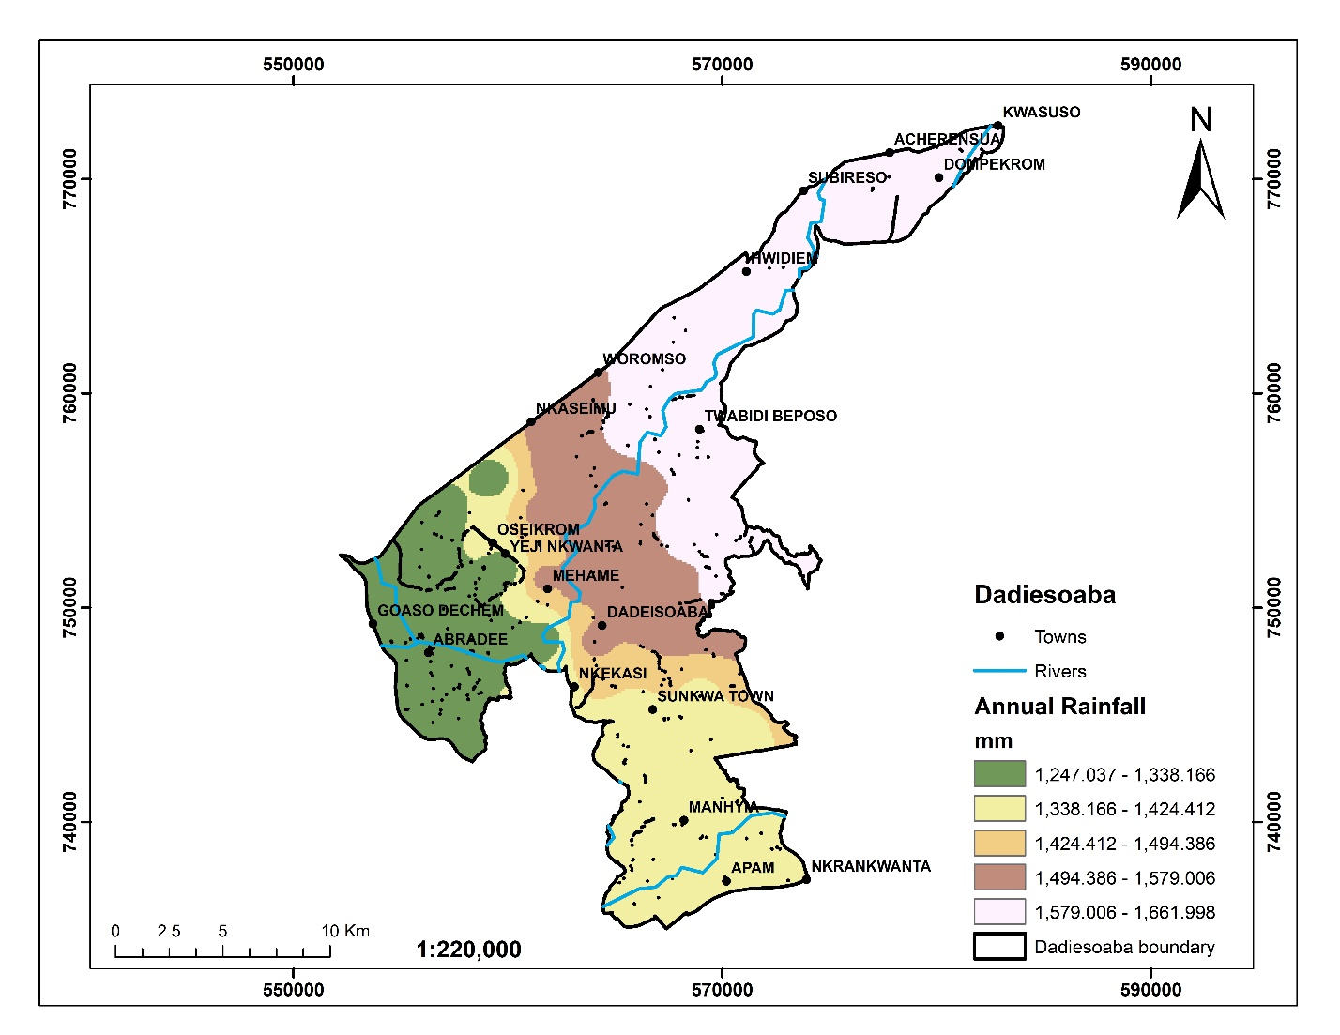

Figure 3.8 Rainfall map of Dadiesoaba cocoa district

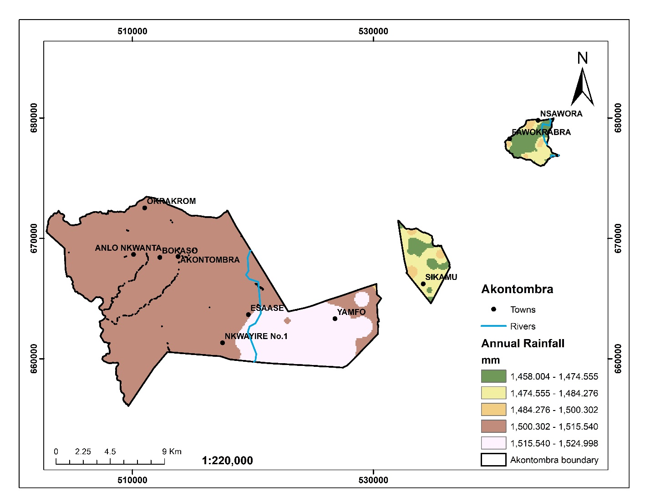

Figure 3.9 Rainfall map of Akontombra cocoa district

### 3.2.1.5 CSSVD

The spatial occurrence of the CSSVD disease in the Akontombra and Dadiesoaba cocoa districts (figure 3.10 and 3.11) was collected from the Cocoa Health and Extension Division (CHED) of the Ghana Cocobod office in the Sefwi-Akontombra district. Collected data that represented cocoa farms and outbreak of the CSSVD were collected in a polygon vector. However, the feature to point extension of the Arc toolbox was used to convert the polygon shapefiles into point data. Recorded CSSVD disease of 1,514 and 92 cases was retrieved for Akontombra and Dadiesoaba cocoa district, respectively.

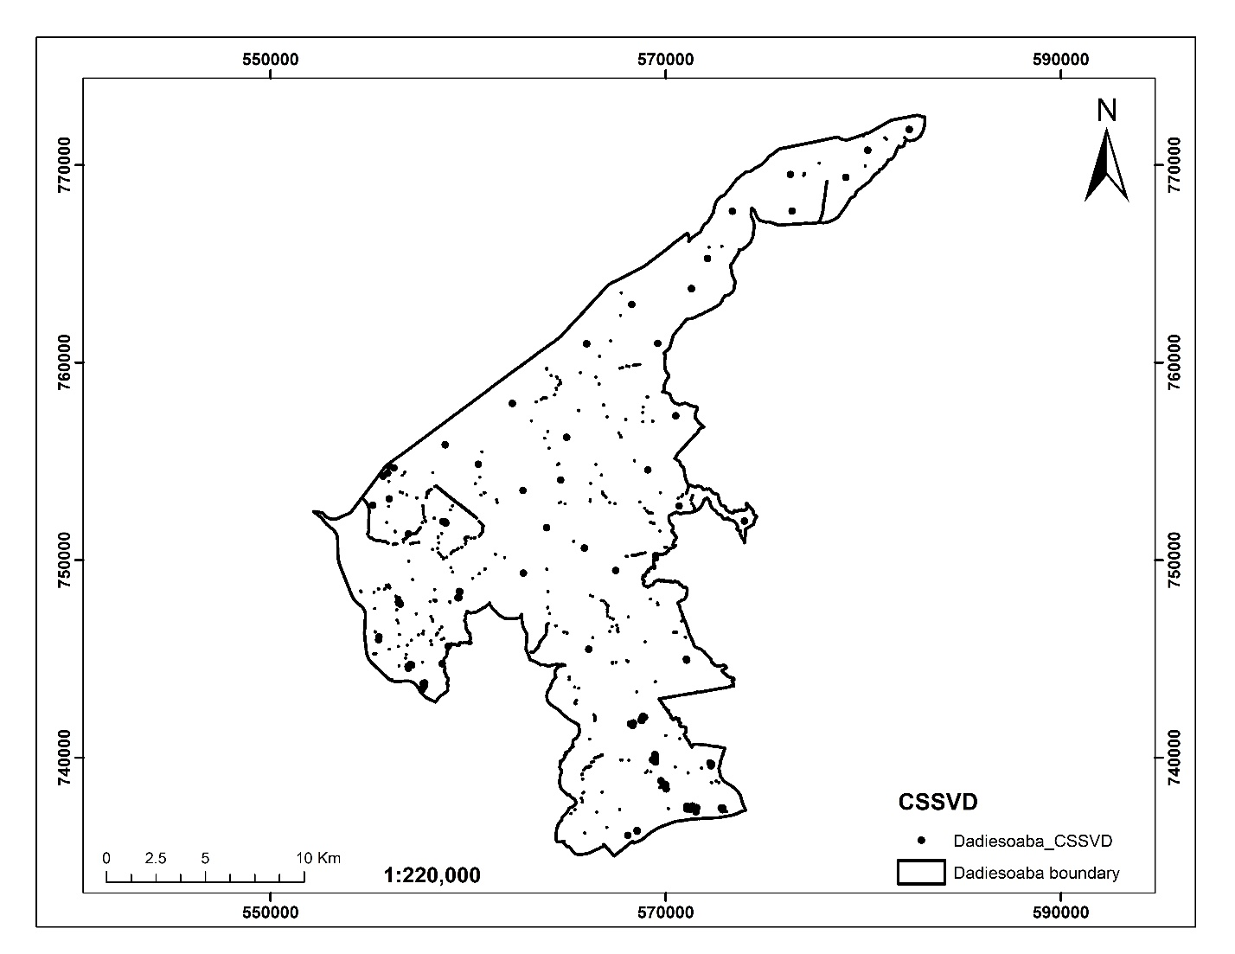

Figure 3.10 Point data of CSSVD cases of Dadiesoaba cocoa district

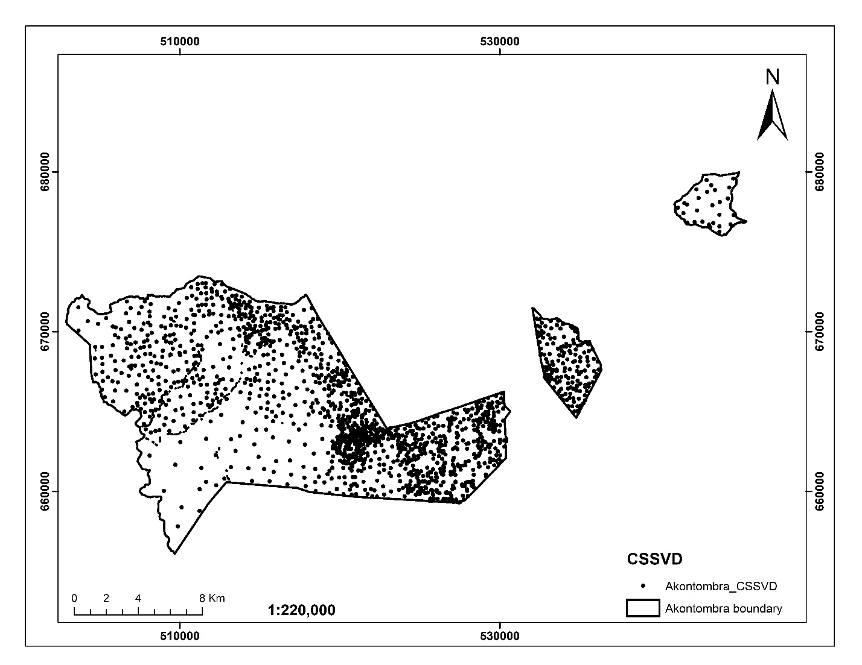

Figure 3.11 Point data of CSSVD cases of Akontombra cocoa district

### 3.2.1.6 Distance from rivers

Euclidean distance tool of the spatial analyst module of ArcGIS 10.5 was used to generate distance from rivers in meters. This is shown figure 3.12 and 3.13.

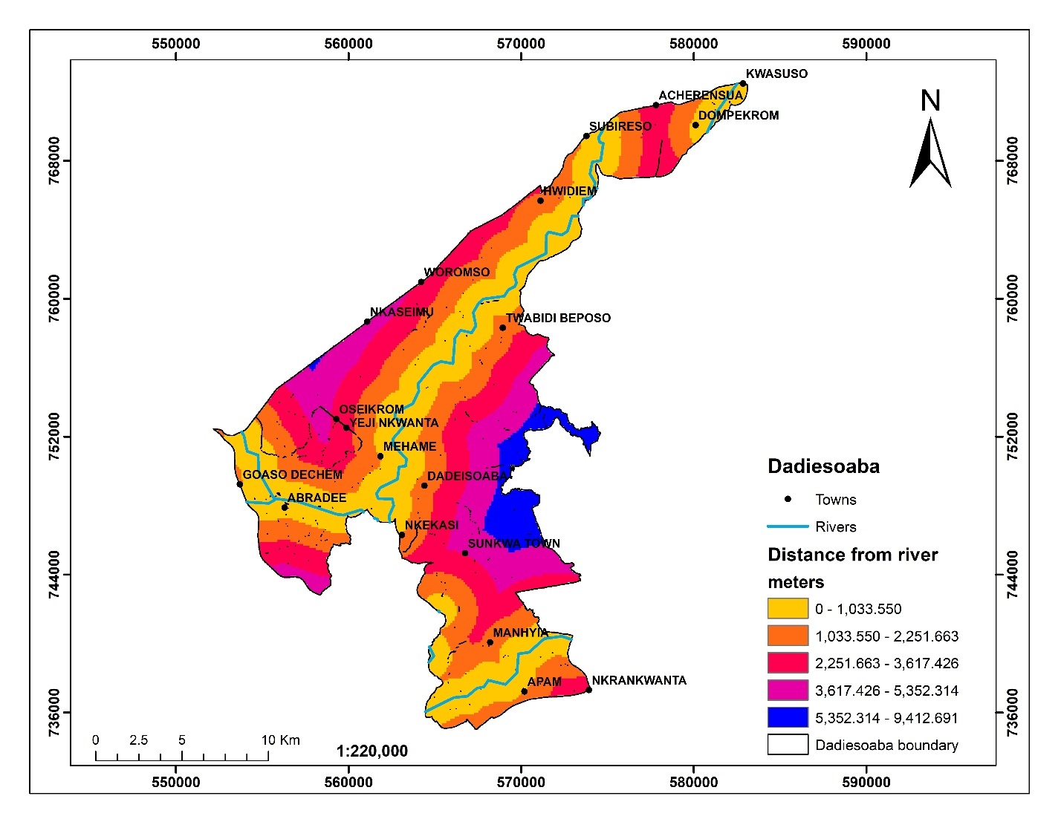

Figure 3.12 Euclidean distance from rivers in the Dadiesoaba cocoa district

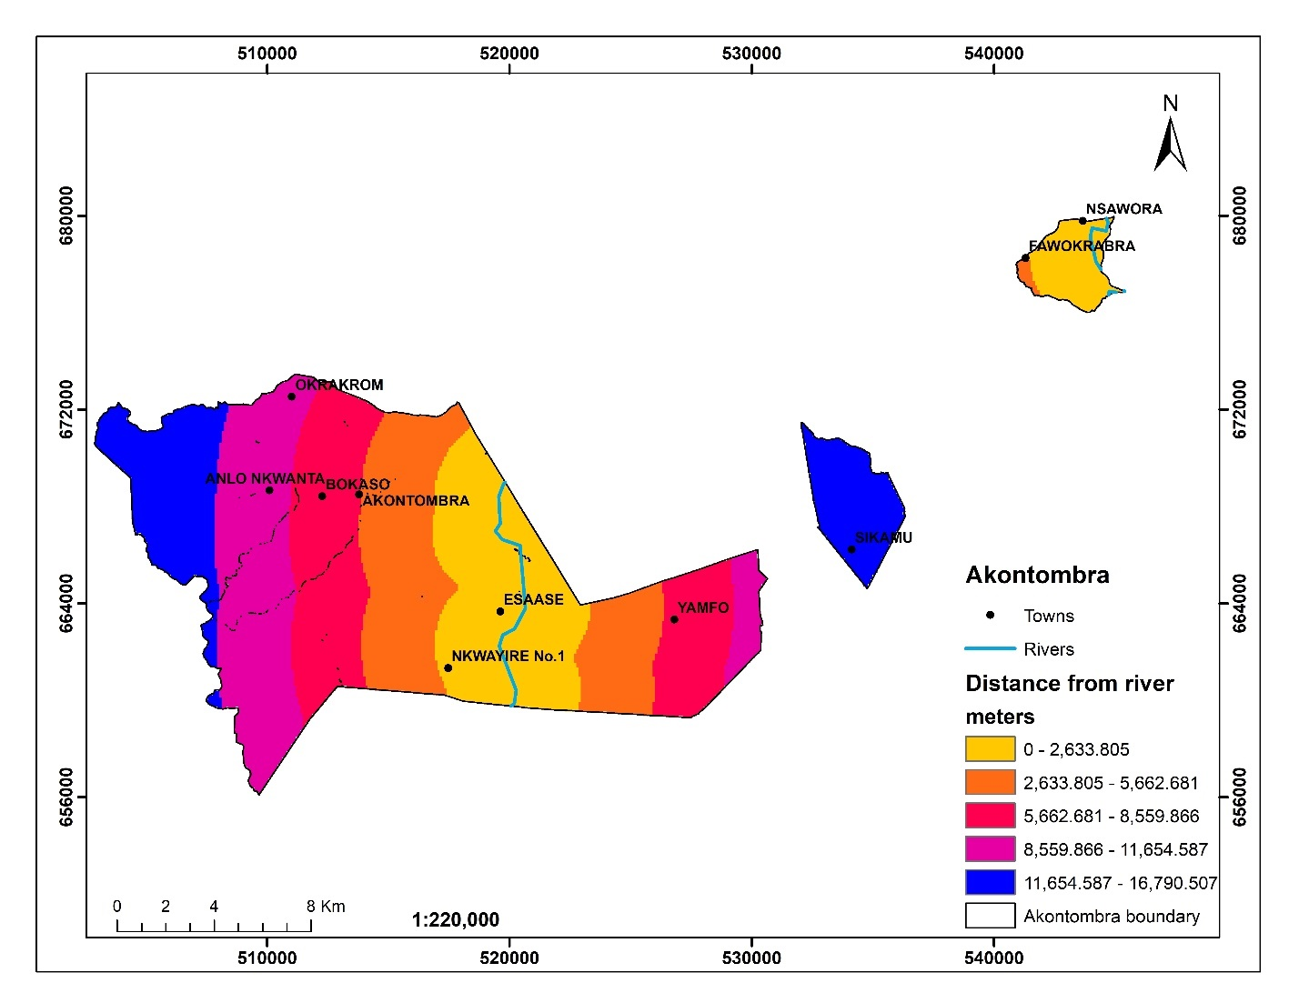

Figure 3.13 Euclidean distance from rivers in the Akontombra cocoa district

## 3.2.2 Software

ArcGIS 10.5 and Microsoft software was used in this study. ArcGIS 10.5 was used for spatial analysis including weighted overlay analysis and an excel developed AHP calculator.

# 3.3 Research Methods

The methods used in achieving the set objective of the research is as shown in figure 3.14.

The methodology is categorized into three main stages: 1) Identify the geographical distribution of the CSSVD disease; 2) Identify ecological factors related to the spread of the disease; and 3) Create vulnerability risk map of the disease.

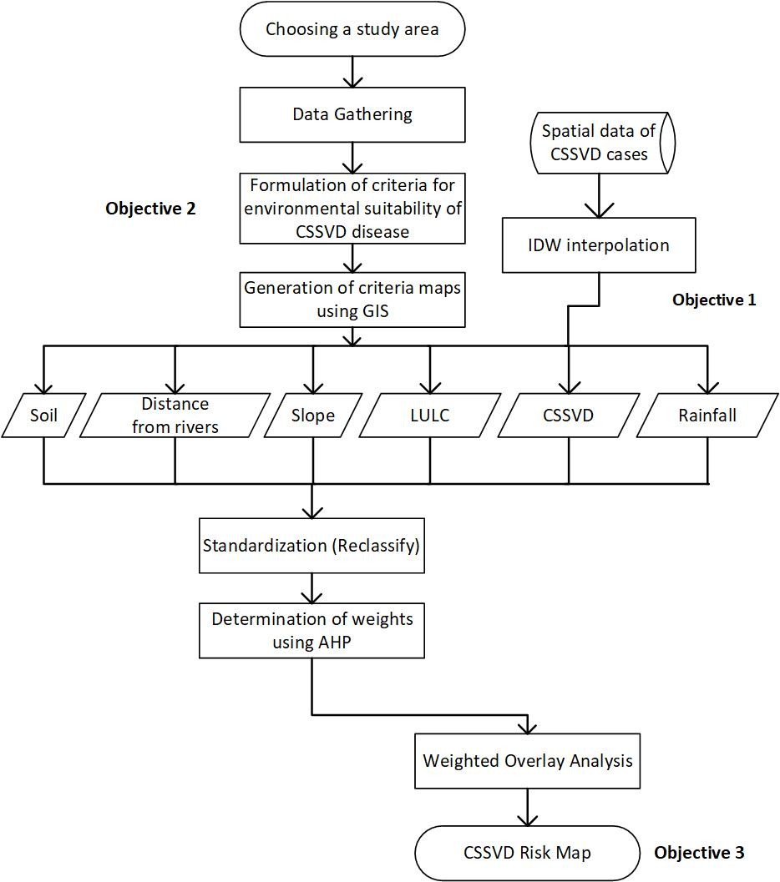

Figure 3.14 Flowchart of methodology

## 3.3.1 Identifying spatial distribution of the CSSVD disease

Using the Inverse Distance Weighing (IDW) interpolation tool in ArcGIS 10.5, the point data with respect to spread (CSSVD incidence) values was estimated at unsampled locations. This helped to create a continuous surface of CSSVD distribution across the study area.

The basic formula for IDW is:

Z(x) = (Σ (zi * (1/di) ^p)) / (Σ(1/di) ^p)

Where Z(x) is the estimated value at point x, zi is the known value at point i, di is the distance between point x and point i, and p is a power parameter.

In this equation, the estimated value Z(x) is calculated as a weighted average of the known values zi. The weighting factor is the inverse of the distance between point x and point i, raised to the power of p. The value of p is typically set to 2, but other values can be used depending on the application.

The interpolated CSSVD incidence data was used to generate thematic maps that visualize the spatial distribution of the disease. Then the continuous raster values were grouped into six classes (very high, high, moderate, low, very low, and extremely low CSSVD zone) using the natural breaks classification in ArcGIS 10.5 to highlight variations in CSSVD severity or prevalence.

## 3.3.2 Identifying environmental factors associated with CSSVD outbreak

Selecting the criteria for rating is an important step in any site suitability assessment process for disease risk mapping. Environmental factors that favour CSSVD occurrence was reviewed from relevant scholar articles in the agroforestry community. A systematic literature review was used in this instance. The systematic literature review involved a comprehensive search of various databases for relevant studies, which was selected based on specific inclusion criteria. The studies were then evaluated for their quality, and the data was synthesized using a standardized approach, allowing for a rigorous and transparent analysis of the environmental factors associated with CSSVD outbreak. A systematic search of the scientific literature using the following databases was conducted: Web of Science, Scopus, and PubMed. The search included articles published between 2000 and 2022. The search terms used included “Cocoa Swollen Shoot Virus Disease”, “CSSVD”, “environmental factors”, “outbreak”, and “West Africa”. The search was limited to peer-reviewed articles written in English.

## **3.3.3 Creation of CSSVD vulnerability map**

To generate risk map of the CSSVD disease, the GIS-based Analytical Hierarchy Process (AHP) method was adapted. The GIS-based AHP approach was utilized to gather, weigh, and assess environmental factors that would affect the disease outbreak. AHP offers a structural framework for which decision factors and criteria may be compared in a pairwise manner. This kind of comparison considerably simplifies decision-making and minimizes complexity. The attribute-factors are represented as map layers in the GIS database, and they include attribute values for each pixel in raster data (Kiker et al., 2005). The steps below were utilized;

1. *Rating Criteria*

The six criteria identified in this study was compared and rated based on the intensity of importance. Due to the comparative analysis of the effect of solar reflection on solar system position, this study assigned relative values of 100, 75, 50, and 25 for the six criteria, where the conditions at the applicable site were graded as most suitable, suitable, moderate, and unsuitable, respectively. The majority of the class ranges were established at equal distances between very high, high, moderate, low, very low, and extremely low risk categories.

1. *Weighting Criteria*

Saaty invented the AHP approach, which has been applied to decision-making, particularly for determining weightings for several criteria (Saaty, 1990); it has the benefit of eliminating comparisons of complex judgments in pairs. This method is also an essential strategy for assessing the consistency of decisions and minimizing any possible bias in decision analysis. AHP was used to create a hierarchical structure for a collection of criteria by determining the weighting of each criterion during the decision-making process. Each criterion had a value given to it depending on how important it was in relation to the other criteria. Weights were allocated on a scale of 1 to 9 semantic differentials scoring to provide a relative rating of two criteria, with 9 being the greatest and 1 being the lowest, based on Saaty's linguistic measurements (Saaty, 1980).

The next step is a creation of pairwise comparison matrix of the six criteria used in the study. The weight of each criterion is calculated by summing the column values and then dividing by the sum of the same column values to obtain a normalize pairwise matrix. This is achieved using the formular;

Xij

Where Xij is the normalized pairwise matrix, n is the number of criteria, and Cij is the column values of the pairwise comparison matrix

Next, the normalized pairwise matrix is divided for each row by the number of criteria to determine the mean of the values in each row of the normalized matrix using the formular below;

Wij

Where Wij is the relative test weight, n is the number of criteria, and is the row values of the normalized matrix.

The next step is to estimate the Consistency Ratio (CR) to determine whether or not the comparisons are consistent. Using the formular below, the consistency index (CI) must be calculated prior to calculating the CR.

CI = $\frac{(λmax - n)}{(n-1)}$

where λmax is the largest eigenvalue of the comparison matrix, and n is the number of criteria.

Lastly, the CR was computed by dividing the CI by the randomness index (RI), as shown in the formular below. Considered here are the RI values for the appropriate criteria values. Notably, for the AHP to produce significant results, the CR must be less than 10%; otherwise, the pair comparison values must be redone (Saaty, 1990).

CR = $\frac{CI}{RI}$

1. *Standardization of the criteria maps*

It is only possible to compare map attribute scores if the measurement units used are the same. Measuring units are uniformed throughout the standardization process, and as a result, scores lose their dimensionality (Janssen & Van Herwijnen, 2006). Each criteria map was reclassified using the ESRI Spatial Analyst reclassification module, which standardizes the characteristics. The criterion characteristics were transformed into an importance scale from 1 to 10, with 1 representing the least important criteria and 10 representing the most important criteria, using linear transformation.

1. *Weighted Overlay*

The standardized maps for each of the six criteria were integrated using the Weighted Overlay function in ArcGIS 10.3. The score value for each criterion was multiplied by its weight from the paired comparison, and the results were tallied using the formular indicated below.

$$A=wi*r^{}$$

where A is the total score, wi is the weight of criterion i and r is the criterion's standard score. Since the weights of each criterion were added together, the final scores of the combined solution can be stated on the same scale. In addition, the weights assigned to each criterion dictated the level of compromise relative to other criteria, implying that high scores and weightings from standardized criteria may compensate for low scores from other criteria.

# Chapter Four

# RESULTS AND DISCUSSIONS

# 4.1 Results

The results of the modelled geographical distribution of CSSVD, environmental factors which favour the outbreak of the disease, and risk map of the disease transmission are displayed in subsection 4.1.1, 4.1.2 and 4.1.3.

## 4.11 Spatial Distribution of CSSVD disease

The spatial distribution of CSSVD disease in Akontombra and Dadiesoaba cocoa districts are displayed in figure 4.1 and 4.2. The number of the occurrence of CSSVD in the various cocoa farms in Akontombra and Dadiesoaba ranges from 12.003 - 24.999 and 5.000 - 24.995 cases, respectively. The Akontombra cocoa district has a higher incidence of CSSVD in the southeastern and northern areas near Yamfo and Okrakrom. Similarly, in the Dadiesoaba cocoa district, the western and southern regions, including the towns of Manhyia, Apam, Nkrankwanta, Abradee, and Goaso Dechem, have a higher concentration of the disease.

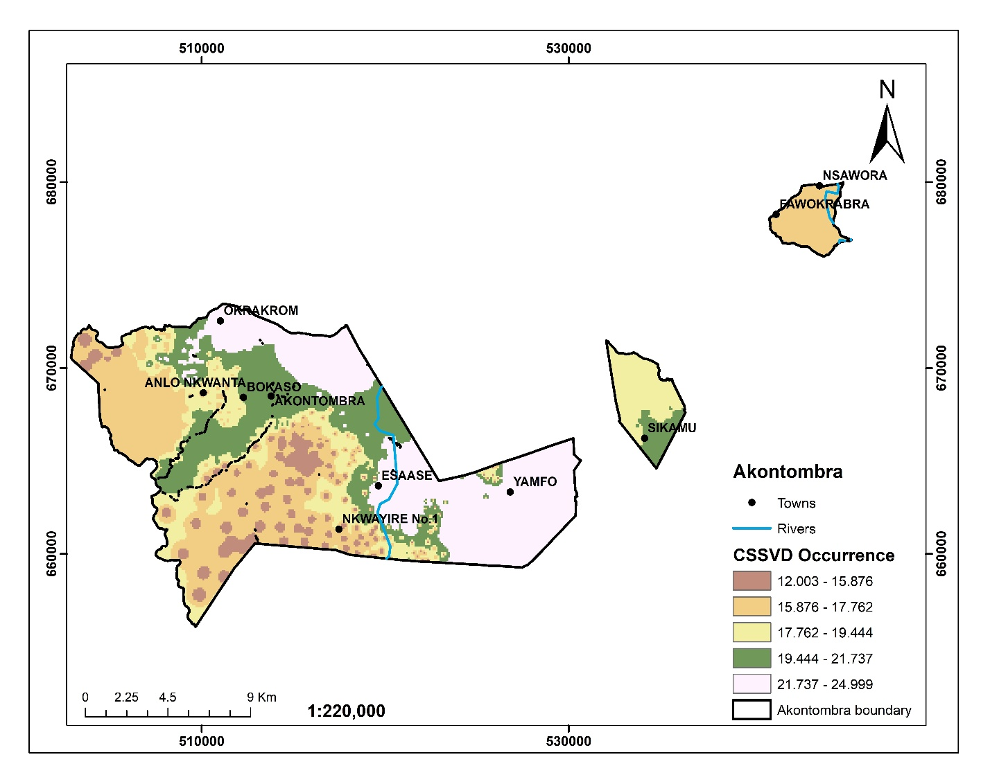

Figure 4.1 Spatial distribution of CSSVD in Akontombra cocoa district

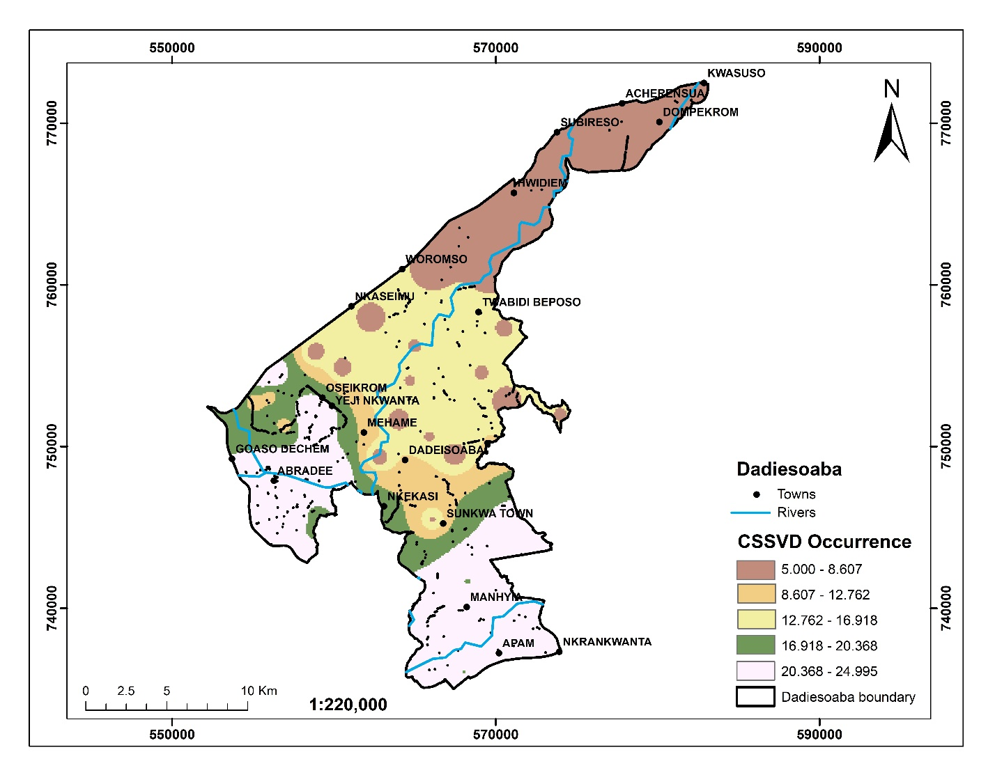

Figure 4.2 Spatial distribution of CSSVD in Dadiesoaba cocoa district

## 4.1.2 Environmental factors Associated with CSSVD Transmission

A total of 12 articles that met the inclusion criteria were retrieved from the databases of Web of Science, Scopus, and PubMed. These articles included both experimental and observational studies that investigated the environmental factors associated with CSSVD outbreaks. The studies were conducted in several West African countries, including Ghana, Cote d'Ivoire, and Nigeria.

The studies identified several environmental factors that were associated with CSSVD outbreaks. These included soil type, climate, shade, and canopy management. Soil type was found to be an important factor in CSSVD incidence and severity, with sandy soils being more susceptible to the disease (Ahenkorah, 1981). Climate and weather patterns, particularly rainfall and temperature, were also identified as important factors, with CSSVD outbreaks being more common during the wet season (Lartey, 2013). Shade and canopy management were found to affect CSSVD outbreaks, with higher shade levels reducing the disease incidence (Domfeh et al., 2011). In addition, the presence of other pests and diseases in cocoa plantations was found to exacerbate CSSVD outbreaks (Ameyaw et al., 2014; Domfeh et al., 2019; Dzahini-Obiatey et al., 2010).

To model the environmental suitability of the CSSVD disease, six factors were identified. These factors determine the degree to which areas are susceptible to the occurrence of CSSVD. These are as follows;

I. CSSVD

II. Rainfall

III. Soil

IV. LULC

V. Slope

VI. Distance from rivers

## 4.1.3 Vulnerability risk map of CSSVD transmission

A multicriteria evaluation was performed to prioritise the degree to which the six (6) factors contribute to spread of the CSSVD disease. Using the AHP, the factors were prioritised according to their weight as shown in the Table 4.1.

Table 4.1 Selected factors and their weights

|  |  |  |  |  |  |  |  |  |  |  |
| --- | --- | --- | --- | --- | --- | --- | --- | --- | --- | --- |
|  |  | CSSVD | Rainfall | Soil | LULC | Slope | Distance from rivers | **Relative weights** | | |
|  |  | 1 | 2 | 3 | 4 | 5 | 6 |  |  |  |
| CSSVD | 1 | 1 | 6 | 3 | 5 | 5 | 5 |  |  | 43.90% |
| Rainfall | 2 | 1/6 | 1 | 1/5 | 1/3 | 1 | 1 |  |  | 5.46% |
| Soil | 3 | 1/3 | 5 | 1 | 3 | 5 | 4 |  |  | 25.35% |
| LULC | 4 | 1/5 | 3 | 1/3 | 1 | 5 | 1 |  |  | 12.67% |
| Slope | 5 | 1/5 | 1 | 1/5 | 1/5 | 1 | 1 |  |  | 5.42% |
| Distance from rivers | 6 | 1/5 | 1 | 1/4 | 1 | 1 | 1 |  |  | 7.21% |

A consistency Ratio of 0.032 (3.2%) was achieved which is less than an alpha value of 0.1 for a 6 x 6 matrix. This indicated that the AHP analysis was consistent. Thus, we can continue with the process of decision making using AHP.

The vulnerability risk map of CSSVD disease in the Akontombra and Dadiesoaba cocoa district are shown in figure 4.3 and 4.4. The CSSVD risk map of Akontombra cocoa district indicates high possibility of the disease occurrence in the northern and eastern parts of the cocoa district. Considering areas which are vulnerable to CSSVD in the Akontombra cocoa district, 27.6% of the area was within a very high CSSVD zone, 19.2% of the area was within a high CSSVD zone, 18.3% of the area was within a moderate CSSVD zone, 28.9% of the area was within a low CSSVD zone, 5.9% was within a very low CSSVD zone, and 0.1% was within an extremely low CSSVD zone.

The CSSVD risk map of the Dadiesoaba cocoa district indicates that the disease is more likely to occur in the southern and western sections of the area. The areas rated as a very high CSSVD zone accounted for 28.9% of the total area, with high, moderate, low, very low, and extremely low CSSVD zone having 11.8%, 8.6%, 32.3%, 16.9%, and 1.5%, respectively.

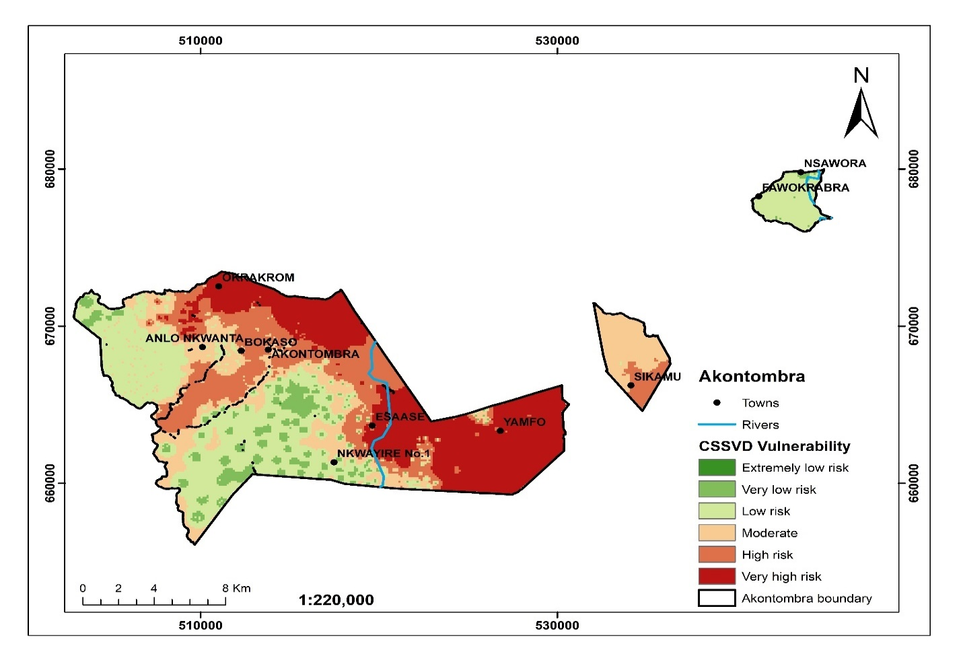

Figure 4.3 CSSVD vulnerability risk map of Akontombra cocoa district

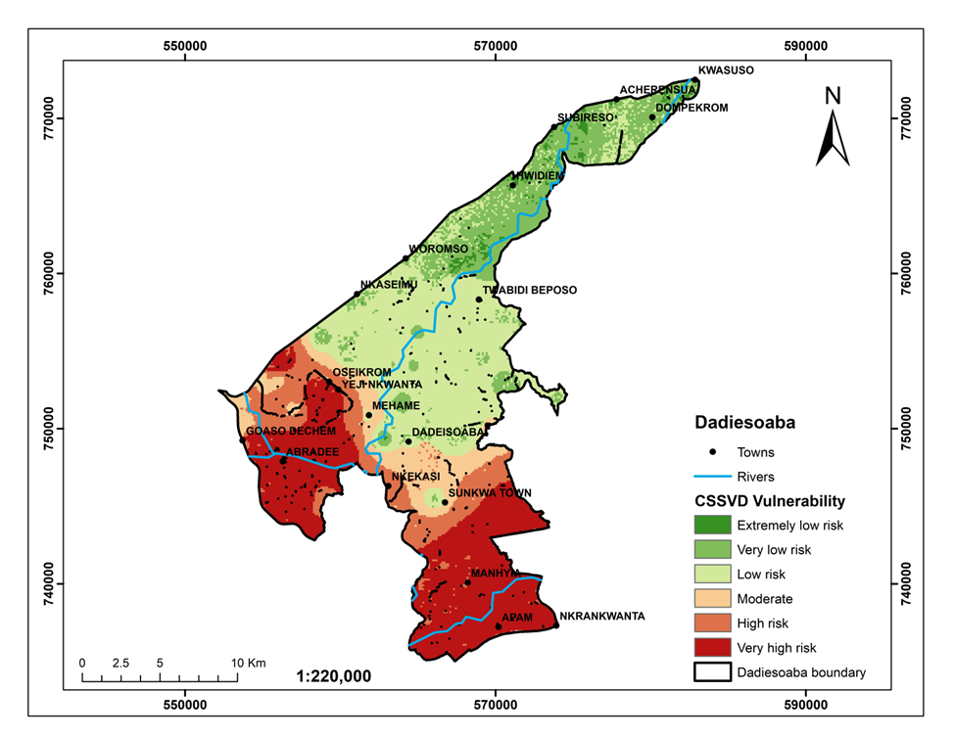

Figure 4.4 CSSVD vulnerability risk map of Dadiesoaba cocoa district

## 4.2 Discussion

## 4.2.1 Spatial trend of CSSVD

The results suggest that there is a spatial distribution of Cocoa Swollen Shoot Virus Disease (CSSVD) in the Akontombra and Dadiesoaba cocoa districts in Ghana (Figure 4.1 and 4.2). The incidence of CSSVD is higher in certain areas in both districts, including southeastern and northern areas near Yamfo and Okrakrom in Akontombra, and western and southern regions including Manhyia, Apam, Nkrankwanta, Abradee, and Goaso Dechem in Dadiesoaba. These findings suggest that the incidence of CSSVD is not uniform across the two cocoa districts and that certain areas are more vulnerable to the disease. This could be attributed to the fact that the less vulnerable disease areas have adopted diversification measures such barrier cropping which has been scientifically tested to have 85% reduction of CSSVD (Andres et al., 2017). The more vulnerable areas may be due to the traditional practice of removing infected trees, planting of resistant breeds, mild strain cross-protection, and control of mealy bug vectors, etc., which has 40% effective rate of the disease (Quainoo et al., 2008).

Several studies have reported the high incidence of CSSVD in the Western North and Western Region of Ghana (Agyeman-Boaten & Fumey, 2021; Ameyaw et al., 2014; Dzahini-Obiatey et al., 2010). The high incidence of the disease is due to the reluctance of farmers to cut down infected trees and lack of diagnostic leaf symptoms in infected cocoa trees (Abrokwah et al., 2016). Moreover, Domfeh et al. (2011) reported that between 2006 and 2010, 64.4% of visibly infected and 'contact' cocoa trees removed across Ghana were located in the northern part of the Western Region. The districts with the highest quantity of infected trees were Essam and Sefwi Bekwai. Recently, there has been a decline in cocoa production rate among farmers in the northern part of the Western Region, particularly in Dadieso and the Sefwi Akontombra District. A 2016 survey by Ghana Cocoa Board (2017) of cocoa farms in the Akontombra District revealed that 85.44% of the 3,029.61 ha surveyed land was affected by CSSVD. Furthermore, the number of cocoa trees affected by the disease in the Akontombra District and Western North were 2,371,224 and 17,115,378, respectively (Ghana Cocoa Board, 2017).

These findings provide important information that can help guide further research into the ecological and climatic factors that may be associated with the spread of CSSVD in these regions. The development of a vulnerability risk map for the disease transmission will help identify areas that are at higher risk for CSSVD and aid in disease management efforts.

## 4.2.2 Environmental factors associated with CSSVD

Cocoa Swollen Shoot Virus Disease (CSSVD) is a major threat to cocoa production in Ghana, and its transmission is influenced by several environmental factors. The results indicate that six factors have been identified as contributing to the environmental suitability for the spread of Cocoa Swollen Shoot Virus Disease (CSSVD). These factors are CSSVD, rainfall, soil, Land Use and Land Cover (LULC), slope, and distance from rivers. These factors can be used to model the environmental suitability for CSSVD and determine the degree to which areas are susceptible to the occurrence of the disease.

The study conducted by Lartey (2013) identified five significant environmental factors that facilitate the spread of CSSVD in cocoa areas in Western North and Western Region. These factors include precipitation, temperature, elevation, slope, aspect, and proximity to forests. The study found that areas with high precipitation, temperature and elevation variability were more susceptible to CSSVD transmission. Furthermore, forests areas had higher CSSVD transmission rates since mealybugs originated from forest (Jeger, 2020). However, slope and aspect were found to have less influence on CSSVD transmission rates. Ostfeld et al. (2005) also observed that areas with steep slopes were less vulnerable to CSSVD, while areas close to rivers were more vulnerable. Another study by Cornwell (2009) and Danquah (2003) identified other environmental factors that contribute to CSSVD transmission in Ghana, such as the age of cocoa trees and the distance between cocoa farms. The study revealed that older cocoa trees were more susceptible to CSSVD than younger ones. Additionally, cocoa farms that were located closer together had a higher likelihood of CSSVD transmission.

Understanding these factors can help in developing effective strategies for CSSVD control and management in Ghana's cocoa production areas.

## 4.2.3 Vulnerability CSSVD map

The results of the CSSVD risk map analysis for the Akontombra and Dadiesoaba cocoa districts in Ghana indicate that there are areas within both districts that are more vulnerable to the spread of Cocoa Swollen Shoot Virus Disease (CSSVD). In Akontombra, the northern and eastern parts of the district were rated as having a high to very high likelihood of CSSVD occurrence, while in Dadiesoaba, the southern and western sections of the district were rated as having a higher risk. These findings can be used to guide disease management efforts by prioritizing resources and interventions in areas that are most vulnerable to CSSVD. Additionally, understanding the spatial distribution of the disease and the areas that are most at risk can inform future research into the specific ecological and climatic factors that contribute to the spread of CSSVD (Domfeh et al., 2019).

The vulnerability risk map is a useful tool for guiding efforts to control CSSVD in the cocoa districts, as it allows policymakers and farmers to identify high-risk areas and prioritize interventions accordingly. This map could also facilitate the allocation of resources, such as the deployment of disease-resistant cocoa varieties, to reduce the vulnerability of cocoa farms to CSSVD.

Overall, the vulnerability risk map provides critical information for decision-making and intervention planning to reduce the spread of CSSVD in Sefwi Akontombra and Dadiesoaba cocoa districts.

**Chapter** **Five**

**CONCLUSIONS AND RECOMMENDATIONS**

**5.1 Conclusions**

This study identified areas within the Akontombra and Dadiesoaba cocoa districts that are prone to CSSVD by considering six factors: CSSVD locations, rainfall, land use and land cover, distance from rivers, and soil type. These factors were incorporated into a database as raster layers using GIS and were weighted using the Analytic Hierarchy Process based on information from previous research. By combining the rated GIS layers and their weightings, a risk map of CSSVD vulnerability was created, classifying areas of the cocoa districts into very high, high, moderate, low, very low, and extremely low risk categories.

In the Akontombra cocoa district, 27.6% of the area is considered very high risk for CSSVD, 19.2% is high risk, 18.3% is moderate risk, 28.9% is low risk, 5.9% is very low risk, and 0.1% is extremely low risk for the disease. According to the CSSVD risk map of the Dadiesoaba cocoa district, the southern and western parts of the region have a higher likelihood of experiencing the disease. 28.9% of the total area is classified as a very high CSSVD zone, while 11.8%, 8.6%, 32.3%, 16.9%, and 1.5% of the area are classified as high, moderate, low, very low, and extremely low CSSVD zones, respectively. The towns of Yamfo and Okrakrom in the Akontombra district and Manhyia, Apam, Nkrankwanta, Abradee, and Goaso Dechem in the Dadiesoaba district are located in areas with a very high risk of CSSVD.

**5.2 Recommendations**

Based on the results of the study, it is recommended that the following measures are adopted to mitigate the risk of CSSVD in the Akontombra and Dadiesoaba cocoa districts;

* Implement good agricultural practices such as proper pruning, fertilization, and pest management to improve the overall health of cocoa trees and reduce their susceptibility to diseases.
* Provide training to farmers on how to recognize and manage CSSVD, including how to properly prune and dispose of infected plants.
* Developing and distributing resistant varieties of cocoa plants to farmers.
* Establishing a system for monitoring and early detection of CSSVD outbreaks in cocoa districts.
* Implementing quarantine measures to prevent the spread of CSSVD from infected areas to disease-free areas.
* Conducting research to better understand the causes and transmission of CSSVD and to develop more effective control measures.